Download and Install  - Windows & Mac : https://zoom.us/download  - iOS: https://apps.apple.com/us/app/id546505307  - Android: https://play.google.com/store/apps/details?id=us.zoom.videomeetings | Login and Start Zoom  Log in by selecting the Sign In button  Your Zoom Control Panel will automatically appear. It will look like the picture below:  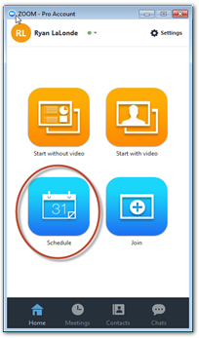
Schedule A Meeting  - Select Schedule to open the Zoom Meeting Scheduler  - Give your meeting a Topic  - Set the meeting Start Date and Duration  - Set Video (when joining a meeting) Host to On (optional)  - Set Participants to On (optional)  - Check Join before host (recommended - allows attendees to test invitation link, audio, and video in advance of meeting)  - Select the blue Schedule button  - Immediately after selecting the blue Schedule button, an Outlook meeting or Gmail invite will appear  - Add your recipients in the "To:" field and Send.  On the day of the meeting everyone will click on the Zoom link inside their calendar invite to join the meeting.  Note: The meeting link is ready immediately. We recommend that you have attendees test the meeting link by clicking the link and joining. If there are any problems, attendees can attempt to resolve them before the meeting starts.  If anyone invited to the meeting does not have a device, they can connect by dialing the phone number in the invitation. | 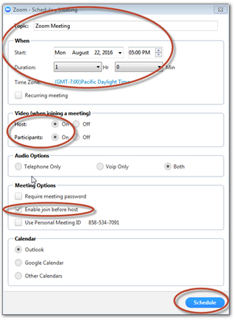  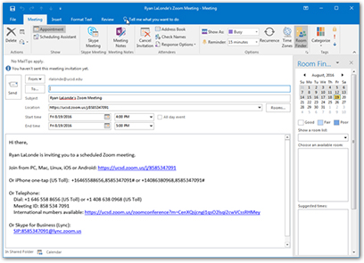
Join a Meeting  Join Using a Link if you were sent a link to join a Zoom meeting, just click the link and follow the on-screen instructions to join the meeting.  Join Using a Meeting ID  1. Open the Zoom Application.  2. Click the blue Join a Meeting button.  3. Enter your 9 or 10 digit Meeting ID (that was in the calendar invitation) and Your Name. | Quick Tips for Using Zoom  - If you are using an external camera and/or microphone be sure to plug them in before opening the Zoom application.  - Use of a headset is recommended if possible.  - Only 1 microphone and speaker system should be active per physical location. Otherwise the 2 systems may cause a loud screeching sound.  - Be sure to mute yourself when you are not speaking.  - Use the Chat feature to ask questions without interrupting the speaker.

Zoom Keyboard Shortcuts for the things you do all the time.
- Ctrl+Alt+Shift: Move focus to Zoom's meeting controls
- Alt: Turn on/off the option “Always show meeting control toolbar” in Accessibility Settings
- Alt+V: Start/Stop your Video
- Alt+A: Mute/unmute your Audio
- Alt+M: Mute/unmute everyone except host Note: For the meeting host only
- Alt+S: Launch share screen window and stop screen share Note: Will only work when meeting control toolbar has focus
- Alt+T: Pause or resume screen share Note: Will only work when meeting control toolbar has focus
- Alt+R: Start/stop local recording
- Alt+C: Start/stop cloud recording
- Alt+P: Pause or resume recording
- Alt+N: Switch camera
- Alt+F: Enter or exit full screen
- Alt+H: Display/hide In-Meeting Chat panel
- Alt+U:Display/hide Participants panel
- Alt+I: Open Invite window
- Alt+Y: Raise/lower hand
- Alt+Shift+T: Screenshot
- Ctrl+2: Read active speaker name

