**What’s Your Favorite Color?**  Eric Carle and Friends

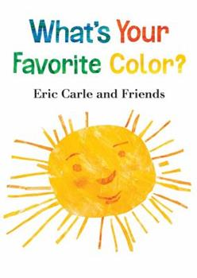

**What’s Your Favorite Color?**  Is a book with unique, colored illustrations. Each page is written and designed by a different children’s book illustrator.

* Take a **book walk** with your child. A book walk is when you and your child explore and talk about the pictures you see in the book without having to read the pages.
* Talk to your child about their favorite colors!

Thank you to **PoWeR! Book Bags**

for the generous donation of this book.

www.powerbookbags.org

**What’s Your Favorite Color?**  Eric Carle and Friends

**What’s Your Favorite Color?**  Eric Carle and Friends



**What’s Your Favorite Color?**  Is a book with unique, colored illustrations. Each page is written and designed by a different children’s book illustrator.

* Take a **book walk** with your child. A book walk is when you and your child explore and talk about the pictures you see in the book without having to read the pages.
* Talk to your child about their favorite colors!

Thank you to **PoWeR! Book Bags**

for the generous donation of this book.

www.powerbookbags.org

**What’s Your Favorite Color?**  Is a book with unique, colored illustrations. Each page is written and designed by a different children’s book illustrator.

* Take a **book walk** with your child. A book walk is when you and your child explore and talk about the pictures you see in the book without having to read the pages.
* Talk to your child about their favorite colors!

Thank you to **PoWeR! Book Bags**

for the generous donation of this book.

www.powerbookbags.org

**Use the QR link to explore a fun color mixing activity!**

**Use the QR link to explore a fun color mixing activity!**

**Use the QR link to explore a fun color mixing activity!**

*

,

