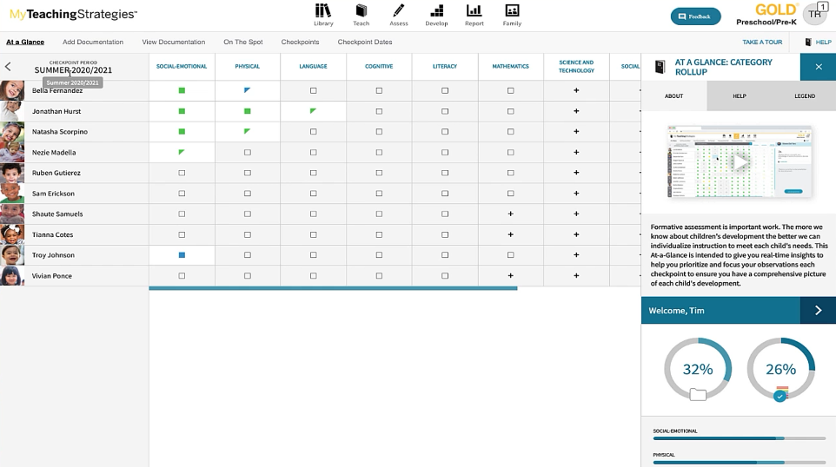
At a Glance Tab
-Shows all students in classroom.
-Defaults to current checkpoint period.
-Quickly identify areas that need attention for each child.
-Legend shows status of documentation
-Hovering over icon will display status of objective.

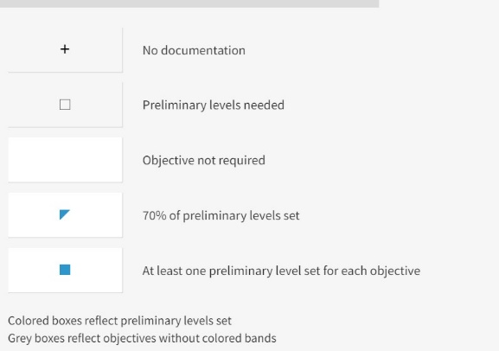
LEGEND
-Square icon- will show when you have some documentation but incomplete documentation for each objective and dimension for the area.
-Triangle-. 70% of objective and dimensions in an area have preliminary levels.
-Filled In Square-One preliminary level selected for all dimension and objectives in an area- filled in square icon.

- Colored of circle or triangle is determined by the most recently selected preliminary level. Color reflets where the child is developmentally on the color band.
- Colors give insight into how each child’s skills are progressing compared to widely held expectations to their age, class, or grade.

Progress Gauges
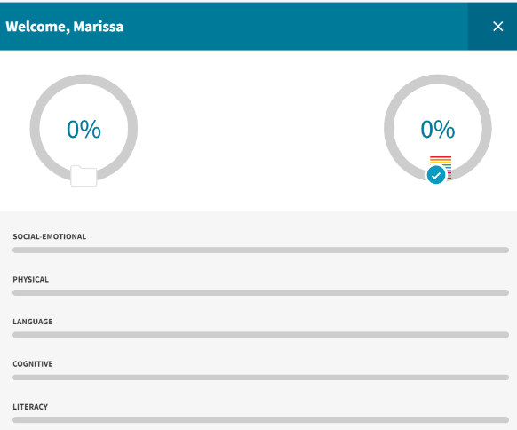
-Provide overview of your overall documentation status.
-Progress Gauges provides overview of overall documentation collection status.
-Left Progress Gauge shows how far along you are with entering documentation (text) for all objective and dimensions.
-Right Progress Gauge tracks your progress towards having at least one preliminary level (color band) for all objective and dimensions for all children in your class.
- Ideally both percentages are close in percentages throughout check point period. This is how you know your setting preliminary levels in a timely manner.

At A Glance: By Developmental Area
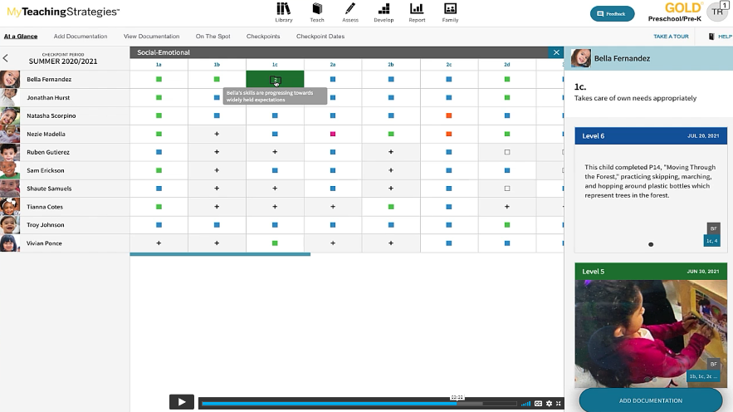

-When clicking on a developmental area (Example: Social Emotional) a list of enrolled children will appear along with the status for each objective in the chosen developmental area. The color of the boxes reflects where the child falls on the color band. Legend applies to other icons as well.
- Hovering over a colored box will identify whether the child is progressing, meeting, or exceeding widely held expectations for their age range.
-Clicking on the colored box will display a file with a number that reflects how many observations were recorded. Along the left side of the screen, documentation will appear with the level and explanation of widely held expectations.

