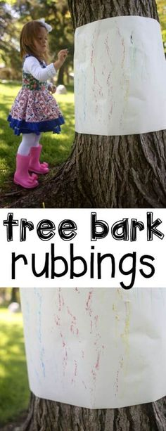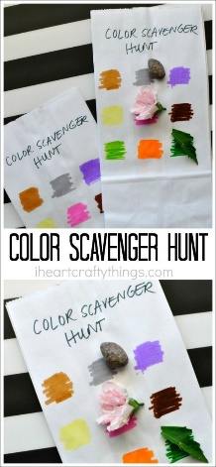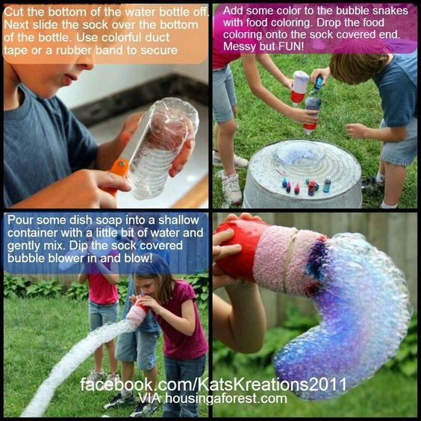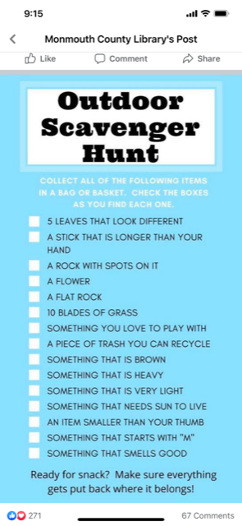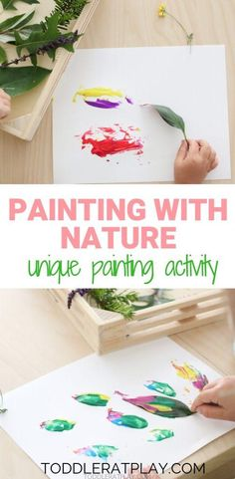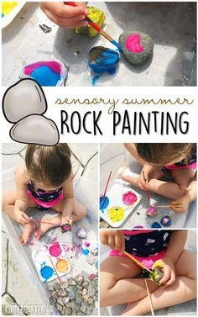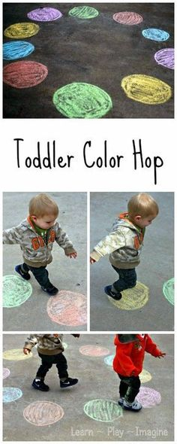

1. **Go on a rock hunt-** Find the best rocks to bring back inside and paint or color with chalk.
2. **Tree bark rubbings-** Place paper over a tree and draw. Talk about the colors and how it feels.
3. **Make a Toddler Color Hop-** Draw different shapes or circles on the ground, have your child jump to the color or shape you name.
4. **Play 5 Senses-** Name one item you **see**, one item you **feel**, one item you **smell**, one item you **hear**, one item you **taste**
5. **Go on a Nature Hunt:**
   1. Bring back a few items you found outside; guess and experiment if they will sink or float in small tub of water.
   2. Find objects that are a certain color (green, yellow, red, etc.)
   3. Play I Spy in nature
   4. Color different squares on a piece of paper (or lunch bag) and take it outside to have your child match outdoor objects to the color blocks.
6. **Sensory Snow-** Fill a bucket with snow and bring back into the house (put towel underneath) let children play in snow with different kitchen utensils. Add squirt bottles with water (options add a little bit of soap, food coloring). Use words to describe what they see and feel. Add blocks and toy figurines.
7. **Explore new walking trails**.
8. **Take Indoor Activities Outside-** blocks, books, Legos, dinosaurs.
9. **Play with bubbles.** Make bubble snakes- Materials needed are washcloth, rubber band, straw and plastic cup. See picture to the right.
10. **Paint with Nature-** Find sticks, leaves, acorns, etc. to paint with.