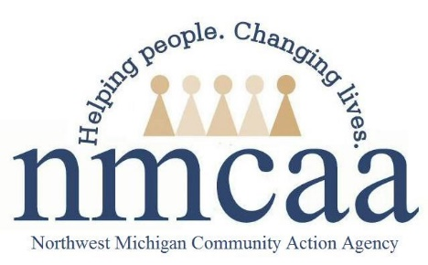

Socialization Policy and Procedure
1302.22, 1302.35
- A minimum of 22 group socializations are provided to each family per year; socialization will be in person whenever possible, and offered virtually if/when the Health Department advises limiting group interactions due to COVID19..
  - Group socializations will be planned by Socialization Specialists, jointly with families and Child Family Specialists. They will be designed to encourage parents to share experiences related to their children’s development with other parents in order to strengthen parent-child relationships and help promote parents understanding of child development.
- A socialization is 90 minutes in length.
- Socialization activities must be intentionally aligned to the home-based curriculum (PAT), school readiness goals, and the Head Start Early Learning Outcomes Framework.
- The socialization planning process and components are to be documented on the Socialization Plan.
- Community partners can be a part of the planning when possible.
- Program Services Coordinators can also be used as a resource.
- Menus are due the 3rd Wednesday of each month to Program Support.
- To reduce barriers to participate in socializations, enrolled families attending socialization will be offered a $10 gas card or a bus pass.
- The CFS Socialization Specialist will complete the EHS Safe Environment Checklist in November, March and July on the space/site where socializations are held most frequently. This data is directly entered into Child Plus.
- The Parents as Teachers (PAT) curriculum is implemented during group socializations.

