- On IPAD, open browser (Safari or Google)
- Go to web.learning-genie.com and sign in. Website will open to your home page.
- On the left side column, select “In-Kind”, then select “Summary Report”
- Select “Add New In-Kind Entry” (orange button upper right)
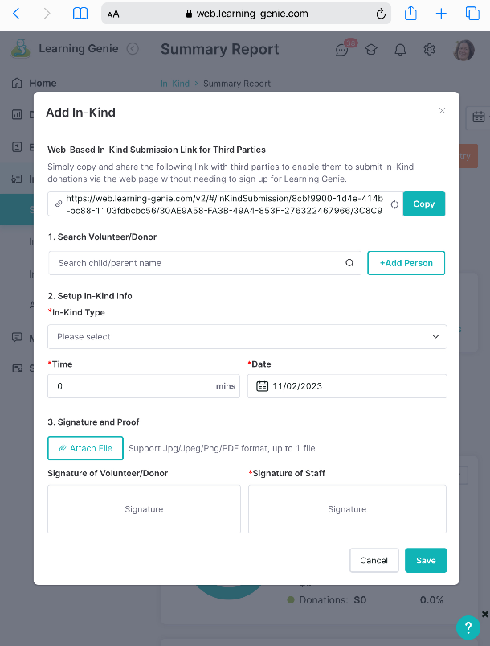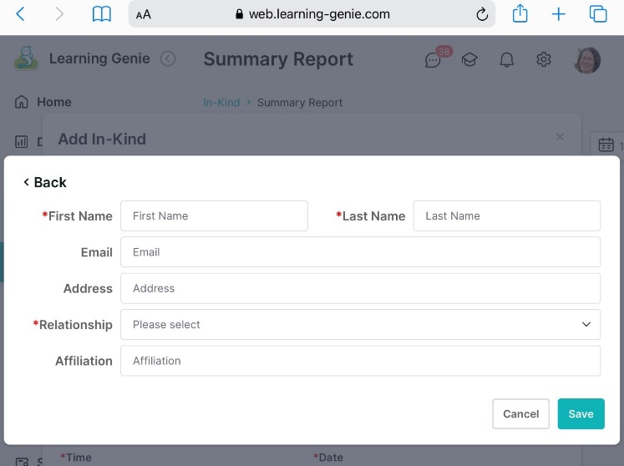
Add In-Kind Screen:
- Search Volunteer/Donor - Start typing the PARENT’S name. Search and select name.
  - If the parent isn’t listed, click ADD PERSON, enter the parent info, and save. This adds the parent to your list for future entries.
Note: the adult name and signature must match
    - Required: First Name, Last Name and Relationship
“Relationship” -select Community Individual
    - Optional: Email, Address, Affiliation
“Affiliation” enter how they are related to child (ex: Parent)

- Setup In-Kind Info – select from list
  - At-Home Activities = extension activities, material prep, health travel time
    - Extension activities – select Add Description then scroll to select the InKind Calendar or “Weekly Extension Activity” and save

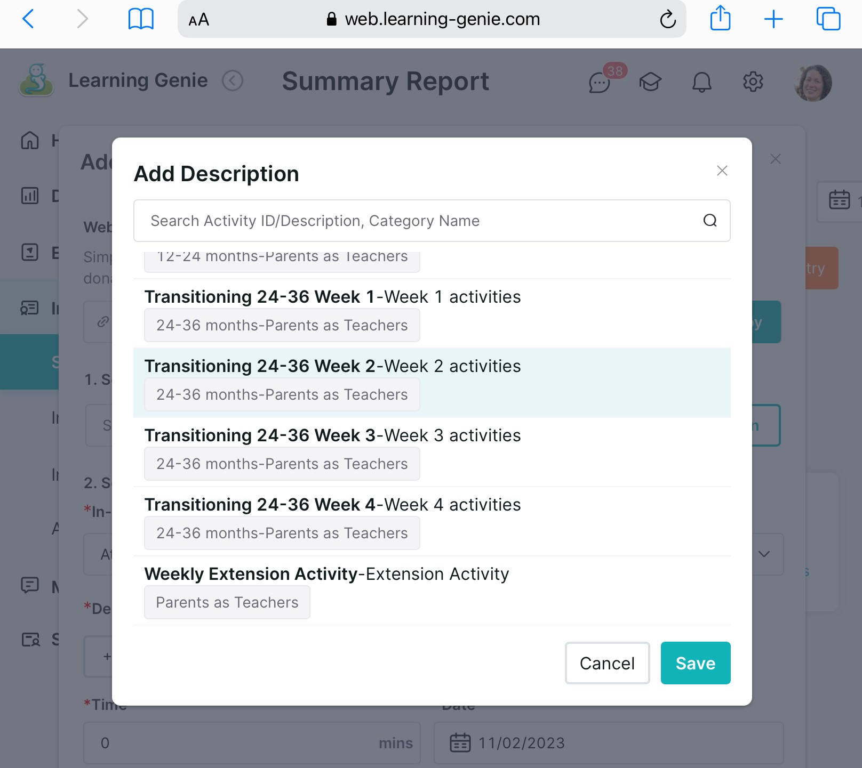

    - Health travel time – select Add Description then “Health Travel Time Round Trip” or “Dental Travel Round Trip” and save

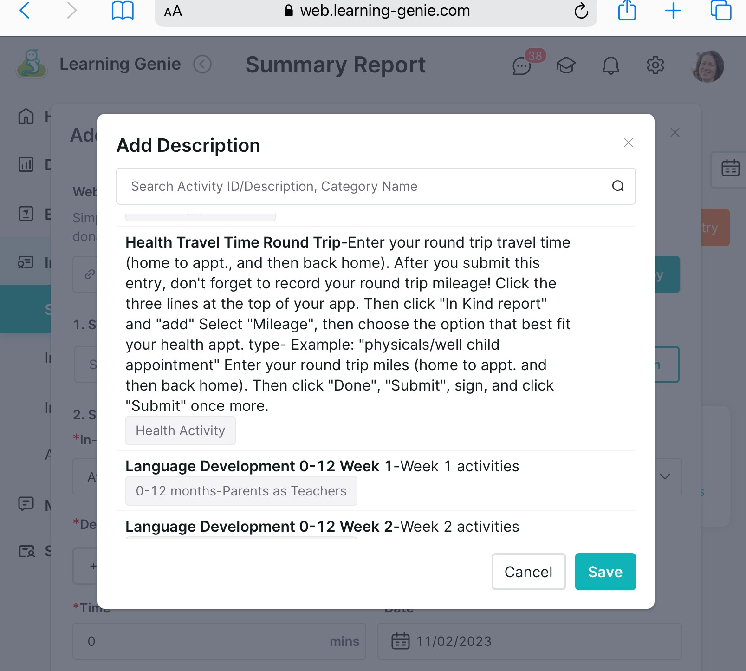

  - Mileage = health miles, IFSP/IEP Meeting (at school/outside of home visit), etc.
    - select Add Description and select from the list

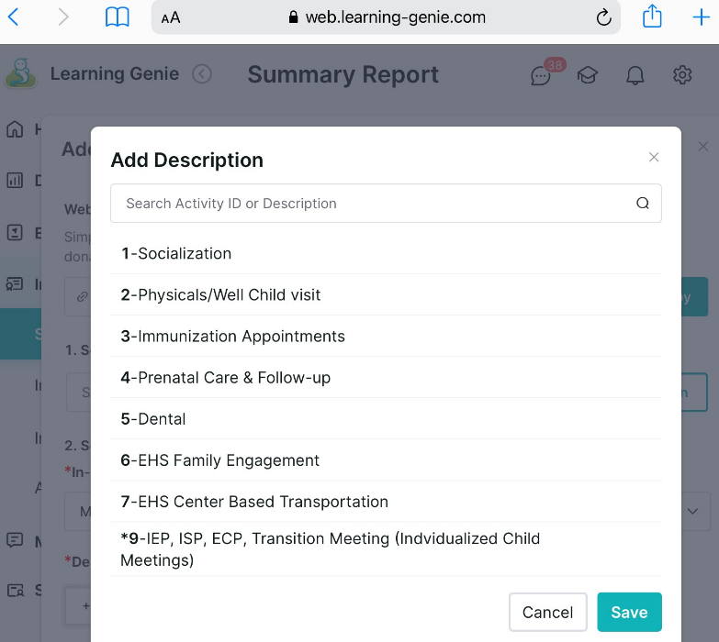

  - Enter Time and Date
- Click Signature of Volunteer/Donor and parent signs with finger/stylus. Submit
- Click Signature of Staff and sign with finger/stylus. Ensure the “acknowledgement” box is checked. Submit
