Consumer Product Safety Commission Recalls

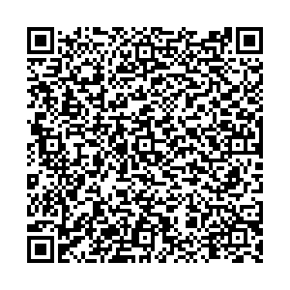

To access the most recent recalls, please scan the QR Code or visit CPSC.Gov

