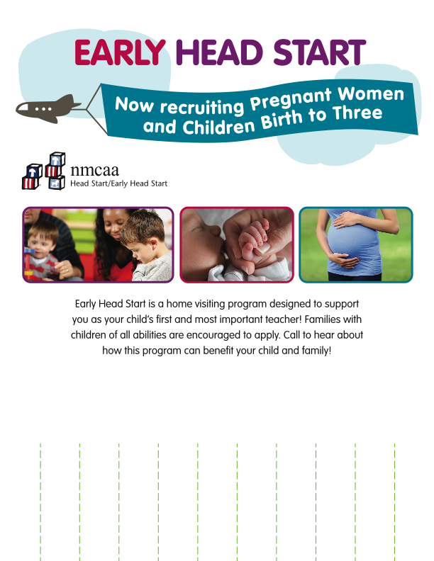

Early Head Start

231.555.5555 or 800.555.5555

Early Head Start

231.555.5555 or 800.555.5555

Early Head Start

231.555.5555 or 800.555.5555

Early Head Start

231.555.5555 or 800.555.5555

Early Head Start

231.555.5555 or 800.555.5555

Early Head Start

231.555.5555 or 800.555.5555

Early Head Start

231.555.5555 or 800.555.5555

Early Head Start

231.555.5555 or 800.555.5555

Early Head Start

231.555.5555 or 800.555.5555

Early Head Start

231.555.5555 or 800.555.5555

Early Head Start

231.555.5555 or 800.555.5555

Please call for an appointment:

231. or 800.