Sunday | Monday | Tuesday | Wednesday | Thursday | Friday | Saturday
Have your toddler throw away their own trash. When they are done with a meal or an activity that needs to be discarded, direct your child to place the items in the trash | Practice sorting items by color, shape, or size. | Practice strengthening your child’s small muscles, so they are ready to cut with child-safe scissors.  Squeeze wet washcloths,  Squirt water bottles, Play with playdough. | Let your child pour their drink into their own cup. Provide a small plastic container with a little water and allow your toddler to practice pouring themselves a drink. | Sing the Clean Up Song with you child! Have your child pick up their toys before taking out a new toy or transitioning to a new activity. | Talk to your child about their emotions. Social/emotional intelligence can be very beneficial in a classroom setting. | Your toddler will have the opportunity to sit and enjoy book readings at school. Create time throughout your day to sit and read to your child.
 |  | 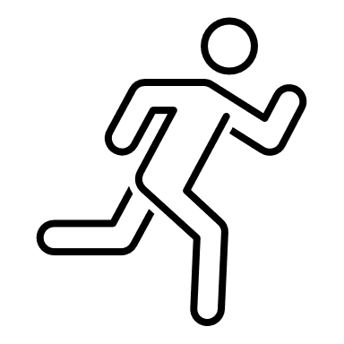
Pat Activity:  Ball Play | Pat Activity:  Sorting | PAT Handout:  Helping Your Child Learn to Cut | Pat Activity:  Pretend Tea Party | Pat Activity:  Putting Things in Order | Pat Activity:  Bears with Feelings | Pat Activity:  Word Book
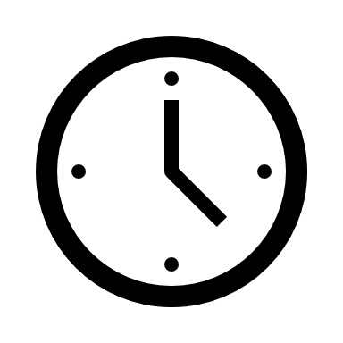 ___________  Estimated: 5 minutes | ___________  Estimated: 5 minutes | ___________  Estimated: 5 minutes | ___________  Estimated: 5 minutes | ___________  Estimated: 5 minutes | ___________  Estimated: 5 minutes | ___________  Estimated: 5 minutes
