Sunday | Monday | Tuesday | Wednesday | Thursday | Friday | Saturday
Place post-it notes, or painters’ tape on a surface that your child must reach to pull off. | Provide a container that allows your child to pretend pour water (or really pour!) into another container to strengthen their hand muscles. | Provide opportunities for your child to piece or stack different items together to build muscles in their fingers. Duplo blocks, wood blocks, peg puzzles, etc. | Let your child color on different objects to encourage their imagination. Examples: A used shipping box, tape paper to a wall,  fingerpaint with washable paint on a window or screen door. | Ask your child to find basic shapes around the house. | Find opportunities throughout your day to build muscles in your child’s legs. Help them walk upstairs, climb onto the couch, or crawl up a play structure. | Have your child assist you with tasks around the house. Let them help you sweep the floors or wipe the table off after a meal.
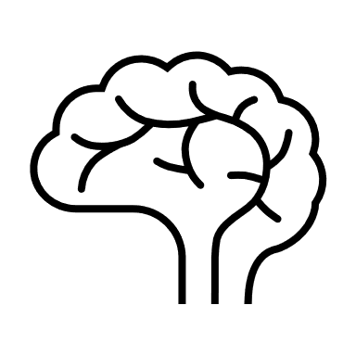
Pat Activity:  Pull Toys | Pat Activity:  Pretend Picnic | Pat Activity:  Puzzle Box | Pat Activity:  Scribbling with Crayons | Pat Activity:  Shape Sorter Box | Pat Activity:  Step Aerobics | Pat Activity:  Sweeping into a Square
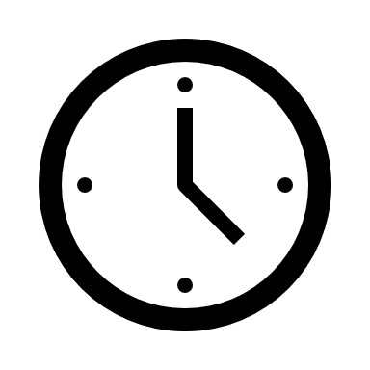 ___________  Estimated: 10 minutes | ___________  Estimated: 10 minutes | ___________  Estimated: 5 minutes | ___________  Estimated: 5 minutes | ___________  Estimated: 5 minutes | ___________  Estimated: 15 minutes | ___________  Estimated: 5 minutes
