Sunday | Monday | Tuesday | Wednesday | Thursday | Friday | Saturday
Have your toddler watch you drop a safe toy into a bowl or container. See if they can pull the toy out. | Use a large stuffed animal that is just a little out of reach of your child. See if they can pull it towards themselves. | Crawl beside your child. Race with them down a hallway or open space. | Find safe objects that allow your child to either push or pull around the house. Ex. Box, toy cart, ottomans. | Play rhythmic music to encourage your child to dance. Join in on the fun! | During mealtimes provide opportunities to allow your child to use a fork or spoon. | Provide crayons and paper to your child to practice making marks on paper. Talk to you child about the colors they are using.
Pat Activity:  Baby Discovery Jug | Pat Activity:  Blanket Pull | Pat Activity:  Cereal Box Road | Pat Activity:  Push-Pull Toy | Pat Activity: Sing-A-Song | Pat Activity:  Snack Time | Pat Activity:  Using Fingers
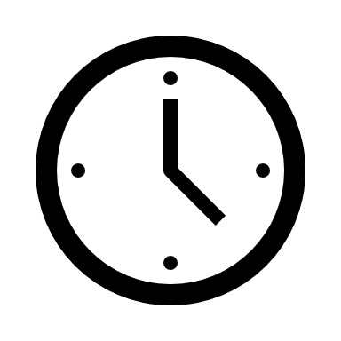 ___________  Estimated: 5 minutes | ___________  Estimated: 5 minutes | ___________  Estimated: 5 minutes | ___________  Estimated: 5 minutes | ___________  Estimated: 5 minutes | ___________  Estimated: 5 minutes | ___________  Estimated: 5 minutes

