Sunday | Monday | Tuesday | Wednesday | Thursday | Friday | Saturday
Pick a shape (like a circle) and identify it for your child throughout the day. Ask your child if they see the shape anywhere. | Identify body parts. Stand in the mirror with your child so they can see their own eyes, nose, ears, mouth, etc. | Have familiar books available for your child to look at throughout the day. Do you hear him “reading” parts of the book from memory? | Identify different words throughout the day that rhyme.  “Hat and cat rhyme. They sound the same at the end.” | When your child shows you something they have created, describe what they are showing you to add new words to their vocabulary.  “You used red to make a circle.” | While reading to your child, pause and ask your child questions about what they see on the pages. | Sing along with your child to their favorite songs.
Pat Activity:  Shape Hop | Pat Activity:  What My Body Can Do | Pat Activity:  Word Book | Pat Activity:  Learning Fingerplays | Pat Activity:  Fingerpainting | Pat Activity:  Word Book | Pat Activity:  Blowing in the Band
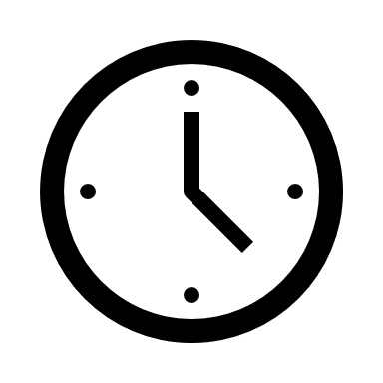 ___________  Estimated: 5 minutes | ___________  Estimated: 5 minutes | ___________  Estimated: 5 minutes | ___________  Estimated: 5 minutes | ___________  Estimated: 5 minutes | ___________  Estimated: 5 minutes | ___________  Estimated: 5 minutes
