Sunday | Monday | Tuesday | Wednesday | Thursday | Friday | Saturday
As your child plays with blocks, count to him how many he stacks or lines up. | Ask your toddler to follow simple directions.  “Put your cup on the table.”  “Find your shoes” | When your child is sad or when she hurts herself, verbalize her emotions.  “You were sad when Sam took your toy.”  “You are laughing, that was funny.” | As you read a book, drag your finger under the words you are reading. This helps your child understand that letters and words have meaning. | Play pretend kitchen. Explain to your child what you are doing. “I am mixing the soup.”  Does your child describe what they are doing? Does she give you directions? | Give your child junk mail to explore. Do you hear her “reading” the words? | Pick a fun new word for the day that you can act out. For example, slurp. Slurp your drink loudly through the straw and say the word. This helps your child connect the word to the meaning.
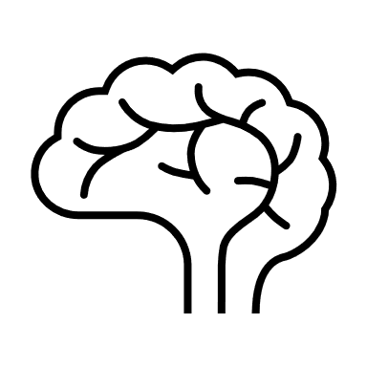
Pat Activity:  Stacking and Building | Pat Activity:  Sweeping Into a Square | Pat Activity:  Take Care | Pat Activity:  Write a Letter | Pat Activity:  Pretend Picnic | Pat Activity:  Write a Letter | Pat Activity:  Parallel Talk
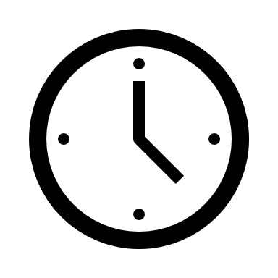 ___________  Estimated: 5 minutes | ___________  Estimated: 5 minutes | ___________  Estimated: 5 minutes | ___________  Estimated: 5 minutes | ___________  Estimated: 5 minutes | ___________  Estimated: 5 minutes | ___________  Estimated: 5 minutes
