Sunday | Monday | Tuesday | Wednesday | Thursday | Friday | Saturday
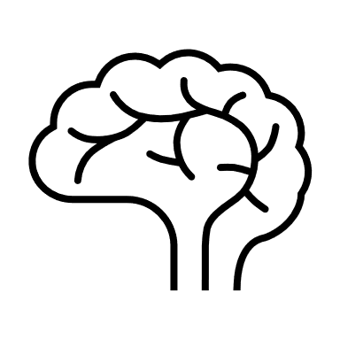  Point out body parts throughout the day. Identify body parts in a book or while they are getting dressed. | While reading a rhyming book or singing a rhyming song, emphasis the rhymes so they stand out from the other words. | Ask your child open ended questions and hear what new words he might be saying. | Take some time to dramatic play with your child. Listen to the words he is using. Is he reenacting something that happened earlier in the day? | Sing nursery rhymes with your toddler. Use finger gestures to enhance the fun! | Chant or sing the words in the next story you read together. | Find opposite words to compare with your toddler. Big and small, Thick and thin.
Pat Activity:  Body Parts | Pat Activity:  Books of Sounds | Pat Activity:  Grab It & Name it | Pat Activity:  Hat Head | Pat Activity:  Here is the Beehive | Pat Activity:  Book of Sounds | Pat Activity:  Homemade Guitar
___________  Estimated: 5 minutes | ___________  Estimated: 5 minutes | ___________  Estimated: 5 minutes | ___________  Estimated: 5 minutes | ___________  Estimated: 5 minutes | ___________  Estimated: 5 minutes | ___________  Estimated: 5 minutes
