Sunday | Monday | Tuesday | Wednesday | Thursday | Friday | Saturday
Count the number of dogs or birds you see while going for a walk or are at the playground. | Practice making lines and circles on paper. Identify the colors being used. | When reading to your child, pause on a page & let your child explore the pictures. Listen for them to talk about the images. | Use painters’ tape to make shapes on the floor. Name a shape & ask your child to jump to it. | Help your child match their socks together and put them away. | Use old mailing labels, tape, or stickers to let your child place on paper. | Play Pick Up 3. When it’s time to clean up, ask your child to count and pick up 3 items to put away.
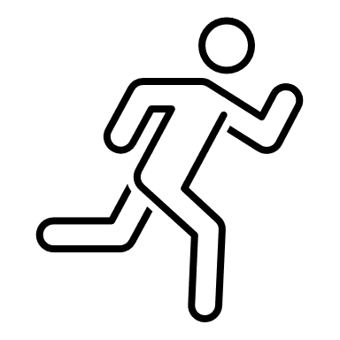
Pat Activity: Nature Walk | Pat Activity:  Tie-Dye Fun | Pat Activity:  Word Book | Pat Activity:  Memory Game | Pat Activity:  Matching Game | Pat Activity:  Sticky Paper Collage | Pat Activity:  Counting
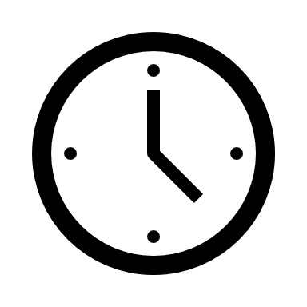 ___________  Estimated: 5 minutes | ___________  Estimated:10 minutes | ___________  Estimated:10 minutes | ___________  Estimated:10 minutes | ___________  Estimated:5 minutes | ___________  Estimated:5 minutes | ___________  Estimated:10 minutes

