Sunday | Monday | Tuesday | Wednesday | Thursday | Friday | Saturday
Let your child bathe a baby doll with a washcloth and name body parts as they wash the baby doll. | Sort toy cars with your child by color and size. | Sing a familiar song w/ your child. Pause before finishing the last word. Wait for her to respond with a word, sound, or eye connection | Collect big and little items and talk to your child about the size differences. Use new words to describe the items. | Place different colored paper or hand towels on the ground have your child find objects around the house that match them. | Ask your child to complete 2 tasks. “Grab your sippy cup and bring it to me.” | Sing counting songs with your child. Hold your fingers up in correspondence with the numbers.
 |  |  | 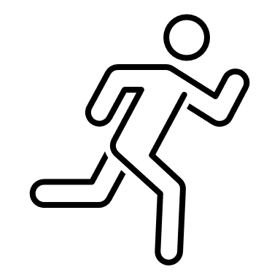
Pat Activity: Body Parts | Pat Activity:  Shape Sorter Box | Pat Activity:  Parallel Talk and Self Talk | Pat Activity:  Nesting Cans | Pat Activity:  Grab It and Name It | Pat Activity: Grab It and Name It | Pat Activity:  Here is the Beehive
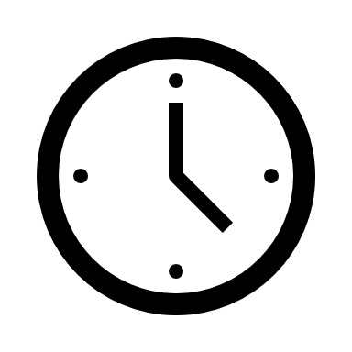 ___________  Estimated: 10 minutes | ___________  Estimated: 10 minutes | ___________  Estimated: 5 minutes | ___________  Estimated:10 minutes | ___________  Estimated: 10 minutes | ___________  Estimated: 5 minutes | ___________  Estimated:5 minutes

