How to Review and Approve Activities (iPad)
1.a. Log into your Learning Genie Educator App, and click the “Settings” icon. Then, go to “Useful Features” > “In-kind”.
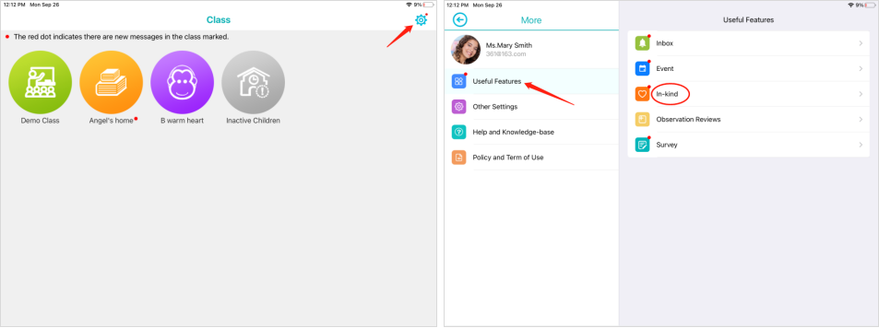
1.b. Click on a classroom, and go to “More”. Then, tap “Useful Features” and select the “In-kind” option, you can also access the in-kind activities.
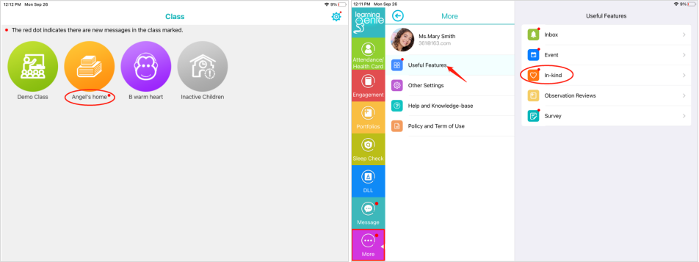
2. Go to the “In-Kind Review” section, and you will be able to find the pending activities that need to be approved.
Note: children with a red dot next to their icons or pictures have pending items.

3. Then you can choose what you want to do with the activities:
- Approve: activities will officially be in the in-kind reports.
- Ignore: activities will not be counted towards your reports.
- Reject: activities will be sent back to the parent to be corrected.
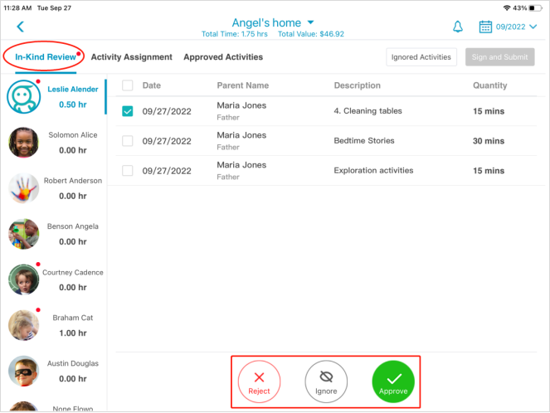
4. At last, click the “Save and Sign Later” button.
All sign offs will be completed by Chris Welton (DMT). You will not need to sign off on any activities.

