Learning Genie - Signing Up Parents

Download Learning Genie for Parents app

Email Invite:
If parent has email in CP and it is linked to Learning Genie already, then an email invite can be sent from CFS.
On your classroom tab, click Parent
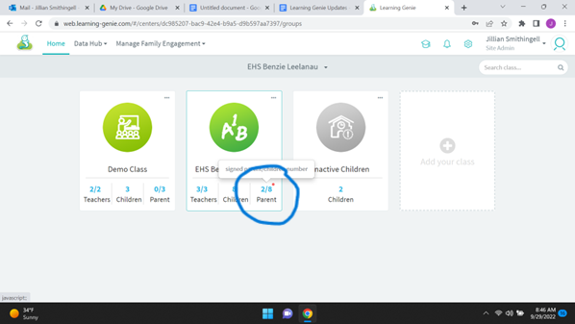

Click green Email Invitation
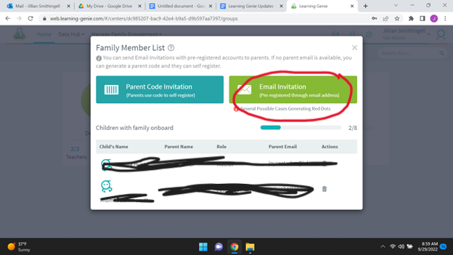

An email is sent to the parent, and this is what they see to get started:
They are provided with login information for when they download the parent app.
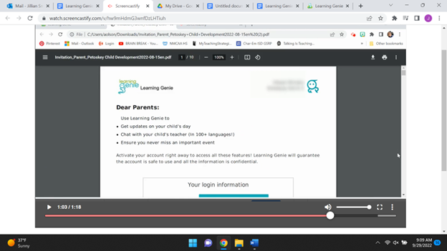
Generate a Code:
If parent does not have email, try to get an email OR can generate a code that parent can input on downloaded app.
On your classroom tab, click Parent

Click on Parent Code Invitation
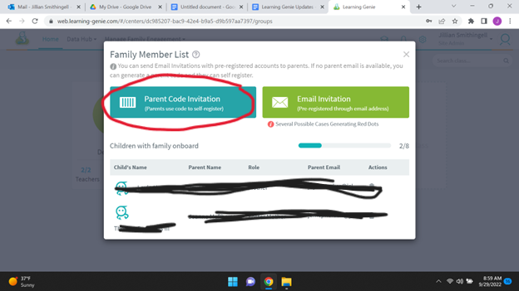

Click on Generate Code
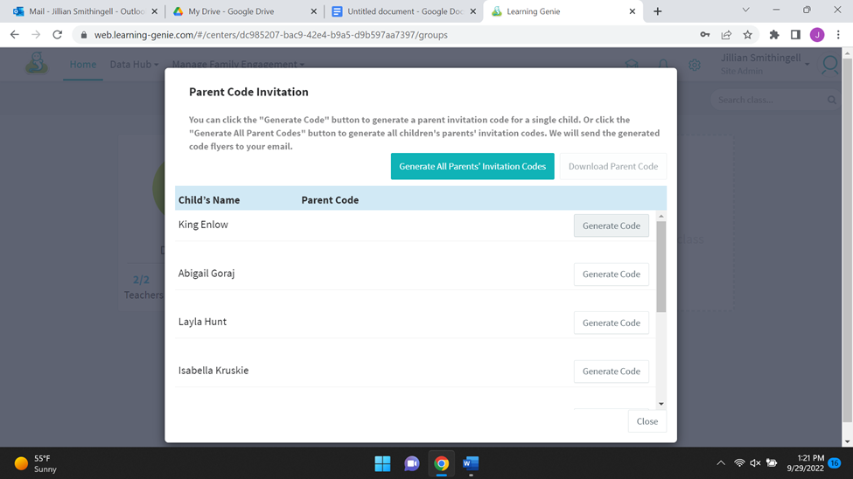

The CFS will receive an email with a code to provide to the parent. There may already be codes that have been generated, you may use one of those (codes are generated specifically for each parent).
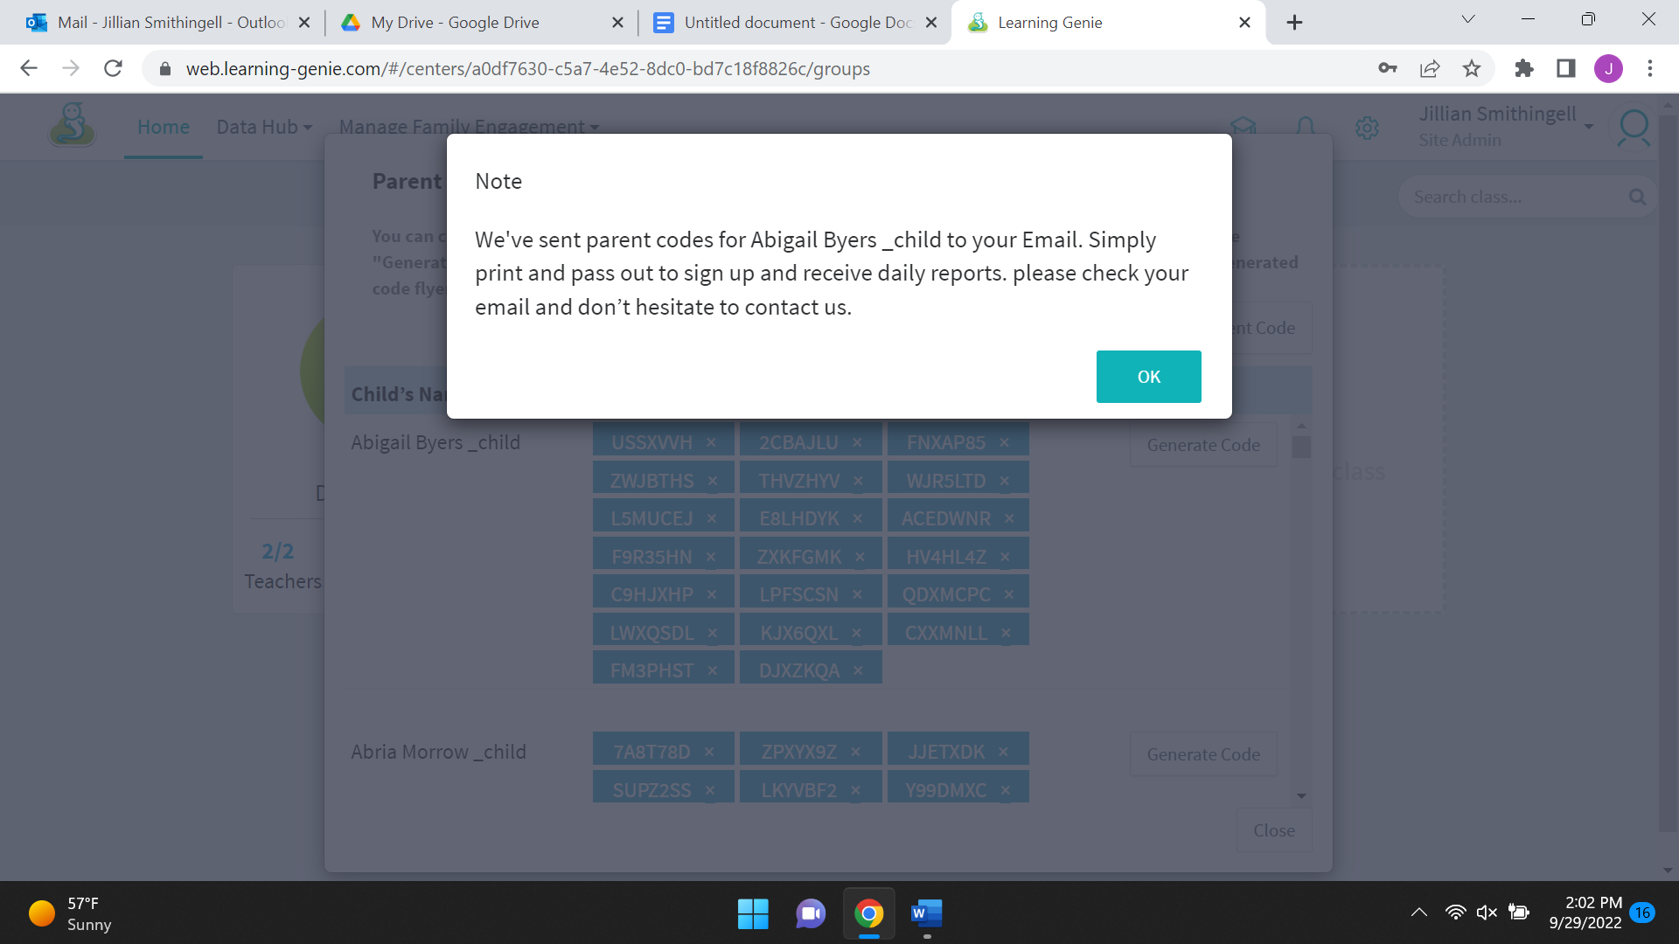
On the parent app, the parent will click on the “Invitation code registration” button at the bottom of their screen, and then enter the code when it prompts them to.
