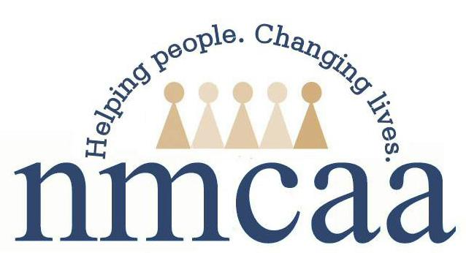

Child & Family Development Program Height and Weight Screening

As a part of the program’s health requirements, height and weight measurements are completed on all enrolled children or collected from their physical form for children that are 2 years old and up. Body Mass Index (BMI) is a number calculated from a child’s weight and height. According to the Centers for Disease Control and Prevention, BMI is used to screen children for healthy weight, obesity, overweight or underweight.

If a child’s Body Mass Index (BMI) is found to be at or above the 95th percentile or at or below the 5th percentile, the program is required to follow-up with parents.

We realize one measurement does not show the full picture of your child’s health history. For this reason, staff will have conversations with you to learn more about your child’s history of height and weight.

We want to be as supportive as possible because your child’s health is a very important part of overall growth and development for school readiness. Staff will be able to provide you with more information on related topics and connect you with services as requested.

4/22 P:\Head Start Files\ADMIN\Procedure Manual\Health\Height & Weight Screening Guidance

