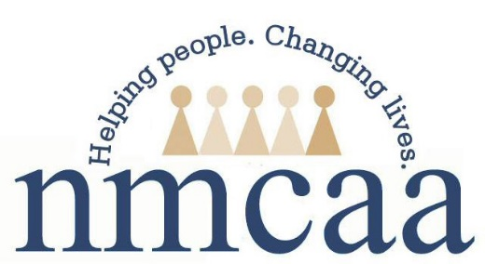
Early Head Start

Meeting

Swivl Videos
Date | time 12.9.19| 9:30-3:30 Location Kalkaska Kaliseum, 1900 Fairgrounds, Kalkaska, Mi 49646
Directions: To access each of the Swivl videos copy and paste the link to your web browser.

https://cloud.swivl.com/v/9b4fee2bc53baaa511a1598674938ed6
 Program Improvement Plan/Small Group Activity 9:50 – 10:20 AM
q Share out and Attendance Data 10:20 – 10:40 AM
❑ Dental/Health Updates and Data 10:50 – 11:10 AM
q HS Parent, Family, and Community Engagement Framework (PFCE) 11:10 – 11:30 AM
  PFCE and School Readiness Data 11:30 – 11:50 AM
https://cloud.swivl.com/v/86ffe11b92ac9940b716aacb4ac5df9f
❑ Acceptance and Enrollment
 Child Development Goals/Small Group Activity

