Creating In-Kind General Weekly Assignments in Learning Genie–

iPad or iPhone (photos are for iPad instructions)
You can send In-Kind assignments to families and track the completion progress now. Here is how.
- On your iPad, log into your Learning Genie App, and click the “Settings” icon. Then, go to “Useful Features” > “In-kind”.
- On your iPhone, log into your Learning Genie App, click on the three lines at upper left, and click “in-Kind Report”
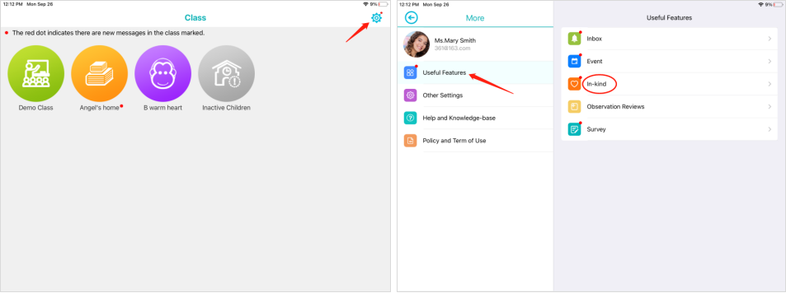
or
- On your iPad, click on a classroom, go to “More”. Then, tap “Useful Features” and select the “In-kind” option, you can also access your assignments.
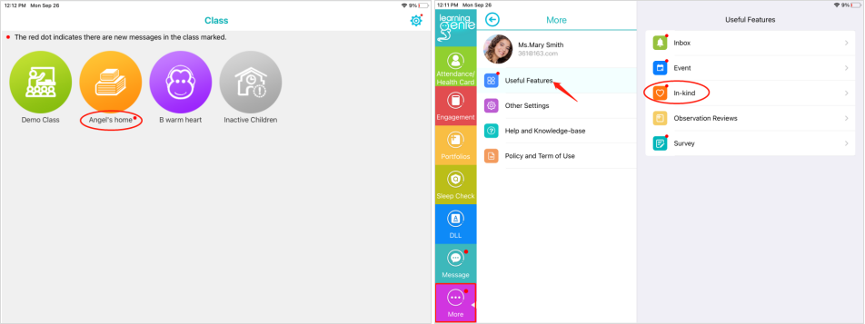
- To create an assignment on your iPad, go to "Activity Assignment", and click the "Create Assignment" button.
- To create an assignment on your iPhone, simply click the “Create Assignment” button.
Note: if you already have some assignments for this month, please click the “+” icon to create a new assignment.
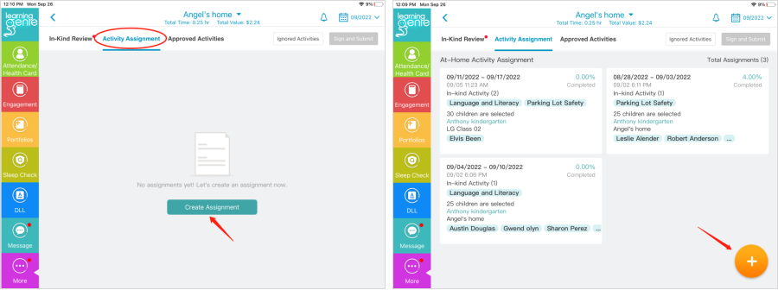
- Select the at-home activities that you are going to include in this assignment. As a general rule, you will assign a “Weekly Extension Activity” each week.
  - You can also add an activity calendar for the family, as appropriate.
- Click “select”
- Next, select “weekly” as the type of assignment.
- In the comment section, write “I-K “ and the date of the hv plan that lists the specific activities. Ex. I-K 6-24.
- You can give hard copies of the chosen calendar at your home visit, or click the camera button in the comment section, to include pictures of the activity calendars for families to view.
- Click the “Select Sites and Classes” button, then click on your county and then your name and the name of the child.
  - If you are on your iPhone, do not click the check box to the left of the site name, unless you wish to include an entire site. Instead, click the actual class or site name. Example: “EHS Emmet” then “EHS Emmet Betty.” You can drill down further to individual children by clicking once more on your caseload name-“EHS Emmet Betty.”
  - Once you see the site, classroom, or child(ren), you want to include, click in the box to the left of the site or classroom name, or names of children, and then click the checkmark in the upper right corner of the screen (after “Select Sites and Classes).
- At last, click the “Submit” button to send this assignment for completion.
Note: you can also customize your comments/instructions, images, and attachments if you want to explain this assignment in more detail.

Creating In-Kind General Weekly Assignments in Learning Genie–
Computer
You can send In-Kind assignments to families and track the completion progress now. Here is how.
- Go to “Manage Family Engagement” > “In-Kind Report”. Then, select Activity Assignment, and click the “Create Assignment” button.
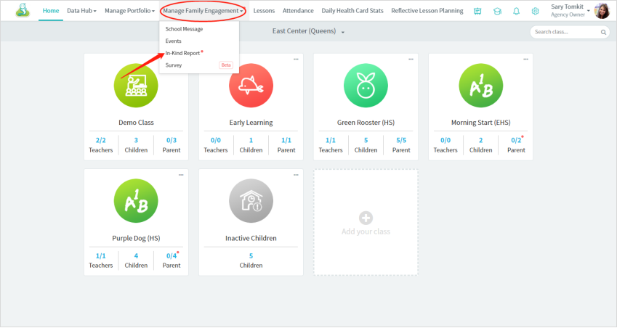
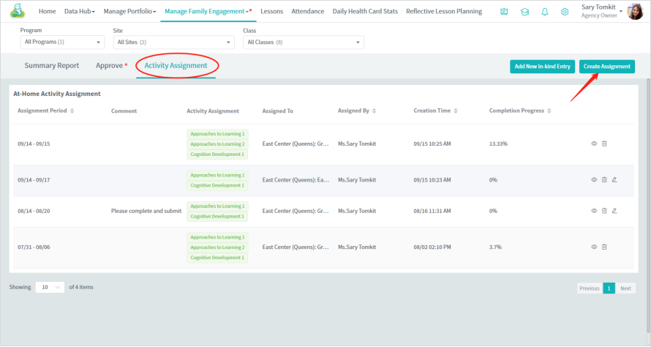
- Select this assignment type (weekly)
- Select the at-home activities that you are going to include in this assignment. As a general rule, you will assign a “Weekly Extension Activity” each week.
  - You can also add an activity calendar for the family, as appropriate.
- Click “select”
- In the comment section, write “I-K “ and the date of the hv plan that lists the specific activities. Ex. I-K 6-24.
- You can give hard copies of the chosen calendar at your home visit, or click the camera button in the comment section, to include pictures of the activity calendars for families to view.
- Click the “Select Sites and Classes” button, then click on your county and then your name and the name of the child.
- Click the “Select Sites and Classes” button to include the children you want to send.
- At last, click the “Save” button to send this assignment to families to complete.
Note: you can also add some comments/instructions, images, and attachments if you want to explain this assignment in detail.
