Main Office:  3963 Three Mile Road  Traverse City, MI  49686-9164  phone (231) 947-3780  (800) 632-7334  fax (231) 947-4935 | Satellite Office:  2202 Mitchell Park, Suite 4  Petoskey MI 49770  (231) 347-9070  (800) 443-5518  fax (231) 347-3664 | Satellite Office:  1640 Marty Paul  Cadillac MI 49601  (231) 775-9781  (800) 443-2297  fax (231) 775-1448 | 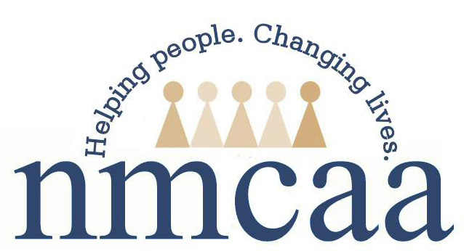

[INSERT DATE POSTIVE CASE WAS IDENTIFIED]

To: Parents or Guardians

We recently became aware that a [staff member/child] in our classroom tested positive for COVID-19. While we are unable to identify the individual due to the confidential nature of the medical information, we can share that it has been [INSERT NUMBER] days since the individual was last in attendance.

What This Means for You and Your Child

1. You may receive a call from the health department. If you or your child were in close contact with this person, you will be contacted by the local health department. Being in close contact means that your child was within six feet of the sick individual for at least 15 minutes.

You or your child may be required to be tested and may also be required to self-quarantine at home for up to 14 days. The local health department will notify you if this action is necessary.

2. Stay home and contact your health care provider if your child is sick. We encourage you to continue social distancing, washing your hands, and monitoring symptoms. If at any time, you or your child begin to develop symptoms of COVID-19 (such as cough, shortness of breath, fever, chills, repeated shaking with chills, muscle pain, headache, sore throat, or new loss of taste or smell), please keep your child home from care and call your healthcare provider for next steps.

It is recommended that you call ahead to your healthcare provider before going to the physician’s office, clinic, urgent care or emergency room so they can be prepared for your arrival. They may also refer you to a testing clinic.

What This Means for Our Classroom To ensure your safety
We have taken steps to properly clean the facility. The [INSERT NAME OF HEALTH DEPARTMENT] has recommend that [INSERT APPROPRIATE STATEMENT:

Complete one of the following:
• our entire facility needs to be closed for [ENTER NUMBER] number of days.
• [ENTER CLASSROOM/SPACE NAME] needs to be closed for [ENTER NUMBER] of days.
• we are not required to close at this time.

You may call me at [INSERT PHONE NUMBER] if you have questions. Thank you for your support in these efforts and your patience, flexibility, and understanding as we work together to promote the health and well-being of our community.

Sincerely,

[SIGNED BY LICENSEE/LICENSEE DESIGNEE]

northwest michigan community action agency
www.nmcaa.net a community action partnership

