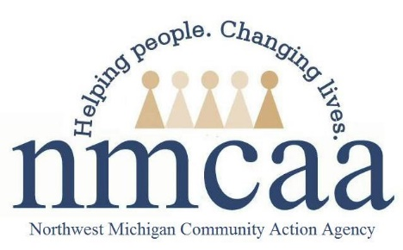

EHS Child Screenings and Assessments Policy and Procedure
1302.33 In collaboration with each child’s parent and with parental consent, a program must complete or obtain a current developmental screening to identify concerns regarding a child’s developmental, behavioral, motor, language, social, cognitive, and emotional skills within 45 days of when the child is enrolled.

- The Ages and Stages 3 Questionnaire is our program’s developmental screening tool and must be completed with each child within 45 calendar days of enrollment. The Ages and Stages Questionnaire results are to be shared with parents and can provide an opportunity to goal-set to build upon strengths if a parent chooses.

- CFSs will be qualified to complete the ASQ-3 after completing the following DVD training courses:
- The Ages and Stages Questionnaires on a Home Visit
- ASQ-3 Scoring and Referral
- All children enrolled in EHS must have a documented evidence based Hearing and Vision screening within 45 calendar days of enrollment (see guidance on hearing and vision form). Child Family Specialists are trained to provide hearing and vision screenings for infants and toddlers to assure that all EHS children are properly screened within this time frame.
- The Infant/Toddler DECA is to be performed within 45 days of enrolling a child. Scoring can be done by the parent or with the parent. The CFS can determine which method will work best with each family. Results, including individualized reports, are to be shared with parents and can provide an opportunity to goal-set to build upon strengths if a parent chooses.
If there are no areas of concern revisit in one year; if there is one area of concern revisit in 3-6 months; if there are 2-3 areas of concern revisit in 6-8 weeks. Contact the Mental Health Manager if concerns remain and/or are serious in nature.
- Recorded, ongoing observations will provide data used to assess EHS children at three month intervals (4 times per program year) using Teaching Strategies GOLD.
- After each checkpoint period, print out a Development and Learning Report and place in the child’s file.
- After each checkpoint period share assessment information with parents in the manner most appropriate for each family. One option, the Development and Learning Report, can be used to share this information. If you choose this method, do not check the “show Objectives and Dimensions number” when you print the report for parents. You may also share assessment information with parents after each checkpoint by using the Family Conference Form under the Communication tab. This option lets you focus on specific areas to highlight growth or areas that can be a developmental focus.
- Results can provide an opportunity to goal-set to build on strengths if a parent chooses.
- If developmental concerns are identified through screenings, assessments, and/or by parental input, the CFS will complete a referral to the local agency responsible for implementing IDEA (ISD, Early-On)
  - Refer to the NMCAA Disabilities Plan (located on the EHS Weebly site under EHS Forms/Special Needs) for information on referral process and interim services.

5/19 p:hs/ehs/enrollment/ 45 day enrollment

