1302.35 Education in home-based programs.
(a) Purpose. A home-based program must provide home visits and group socialization activities that promote secure parent-child relationships and help parents provide high-quality early learning experiences in language, literacy, mathematics, social and emotional functioning, approaches to learning, science, physical skills, and creative arts. A program must implement a research-based curriculum that delivers developmentally, linguistically, and culturally appropriate home visits and group socialization activities that support children’s cognitive, social, and emotional growth for later success in school.
(2) Planned using information from ongoing assessments that individualize learning experiences.
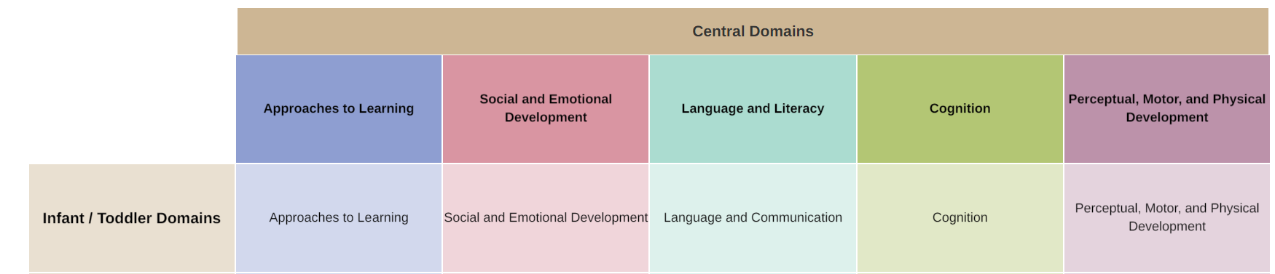

NMCAA EHS Child Development Goal (CDG)
- An NMCAA Early Head Start Child Development Goal is a developmental goal chosen collaboratively by the family and home visitor.
- The child’s developmental goal can be chosen through assessments, parent concerns, child interests, or IFSP.
- The CDG falls into one of the five Early Learning Outcomes Framework Central Domains; Approaches to Learning, Social and Emotional Development, Language and Literacy, Cognition, or Perceptual, Motor, and Physical development.
- The CDG can change when necessary to fit the needs of the child and family.
- Once a goal has been successfully completed, another goal can be discussed and established with the family.
- The goal can change to a different domain when necessary.
- The CDG does not change weekly based on the weekly PAT Activity.
- If a PAT Activity is chosen by the family and the developmental goal isn’t referenced in the “What’s In it For US?” section of the form, the Child Development goal can be added to the PAT Activity to incorporate the child’s development goal or an additional component can be added to support the CDG. For example, through a book activity or through transitions.
- Best practice is to make the goal be small and attainable.
- There may be times when a CDG doesn’t fit into the activity, talk to your PSC, Coach/Mentor about ways to discuss the goal at visit.

Goals Examples
Gross motor: jumping with two feet off the ground | Language/Literacy: Combining two words
Fine Motor: picking up items using pincer grasp | Cognition: Matches objects
Social Emotional: Turn Taking | Approaches to Learning: Follows two step directions

Notes:
- PAT Milestones and TS Gold Reports can be useful tools when deciding on a specific child development goal.
- Self-help, well-being, etc., will be categorized into family goals*
Documentation and Follow-Ups
- The Child development goal is documented on the Personal Visit Planning Guide as a point of reference during a home visit.
- It is acceptable to identify the child development goal anywhere on the Personal VIsit Planning Guide.
  - Write the child development goal along the goal setting line. Identifying that a Child Development Goal is being referenced at the visit.
  - Write Child Development goals at the top of the Personal Visit Planning Guide under “Other Program Responsibilities.” Highlighted on the image below.
- Child development goals should be referenced at every home visit.
- Child development goals do not need to be documented in Child Plus.
