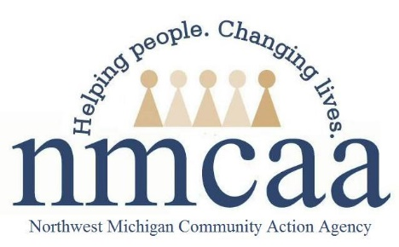

Additional Services for Children with Disabilities Guidance

HSPPS 1302.60, 1302.61, 1302.62, 1302.63
- It is a requirement of Early Head Start to serve children of all abilities and that children with diagnosed disabilities comprise a minimum of 10% of our total enrollment.
- If the CFS suspects that a child might have a delay with speech, motor, etc., the CFS contacts Early On with the parents’ permission so that Early On can complete an assessment to see if the child qualifies for services. If the child qualifies for services, Early On will initiate an IFSP within 45 days of the initial EHS referral. The children receiving Early On services can be counted in our 10% disability count. If a child is assessed at a 50% or greater delay in any developmental area, s/he will be eligible for services through the Intermediate School District (ISD).
- In addition to the initial ASQ screener and ongoing GOLD assessments, CFS’s may choose to use PAT milestones, additional ASQ data, E-DECA information, and/or parent concern to assist with determining need for referral.
- Refer to the NMCAA Disabilities Plan, located in Weebly under Special Needs tab, for information on providing services to children with disabilities and their families.
- An up to date copy of a child’s IFSP/IEP must be uploaded to Child Plus under the “Disability” tab by the PSC
- Developmental concerns and diagnosed disabilities need to be entered into Child Plus under the “Disabilities” tab by the PSC

