**What’s Your Favorite Animal?**  Eric Carle and Friends

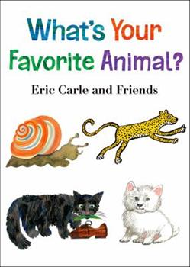

**What’s Your Favorite Animal?**  Is a book with unique illustrations. Each page is written and designed by a different children’s book illustrator.

* Read books aloud to your child. It’s okay if they don’t sit the whole time. They are still listening!
* Talk to your child about their favorite animals!

Thank you to **PoWeR! Book Bags**

for the generous donation of this book.

www.powerbookbags.org

**What’s Your Favorite Animal?**  Eric Carle and Friends

**What’s Your Favorite Animal?**  Eric Carle and Friends



**What’s Your Favorite Animal?**  Is a book with unique illustrations. Each page is written and designed by a different children’s book illustrator.

* Read books aloud to your child. It’s okay if they don’t sit the whole time. They are still listening.
* Talk to your child about their favorite animals!

Thank you to **PoWeR! Book Bags**

for the generous donation of this book.

www.powerbookbags.org

**What’s Your Favorite Animal?**  Is a book with unique illustrations. Each page is written and designed by a different children’s book illustrator.

* Read books aloud to your child. It’s okay if they don’t sit the whole time. They are still listening!
* Talk to your child about their favorite animals!

Thank you to **PoWeR! Book Bags**

for the generous donation of this book.

www.powerbookbags.org

**Family Activity**

**Provide paper and crayons for both you and your child to draw your favorite animals. You might notice your child just makes marks on their paper. That is great! This is the first stage in expressing themselves and building hand muscles for writing and making controlled marks.**

**Statements to make to your child while they are drawing:**

* Tell me about your drawing.
* Wow! You used a red crayon to make your marks!

**Family Activity**

**Provide paper and crayons for both you and your child to draw your favorite animals. You might notice your child just makes marks on their paper. That is great! This is the first stage in expressing themselves and building hand muscles for writing and making controlled marks.**

**Statements to make to your child while they are drawing:**

* Tell me about your drawing.
* Wow! You used a red crayon to make your marks!

**Family Activity**

**Provide paper and crayons for both you and your child to draw your favorite animals. You might notice your child just makes marks on their paper. That is great! This is the first stage in expressing themselves and building hand muscles for writing and making controlled marks.**

**Statements to make to your child while they are drawing:**

* Tell me about your drawing.
* Wow! You used a red crayon to make your marks!

