Finalizing Gold Checkpoints
- Checkpoints can be finalized two weeks prior to the due date. (August 31st, 2022)
- Ready Set Go Videos-Four-minute Videos discussing updates to TSGOLD Finalizing components: https://teachingstrategies.force.com/portal/s/GOLD-ready-set-go-videos
1.Introducing the Checkpoint Dashboard (watched in EHS Academy)
2. Finalizing Checkpoints by child (watched in EHS Academy)
3. Finalizing Checkpoints by class.
*Tip: Many of the pages on Teaching Strategies Gold have a “Take A Tour” button to click providing a short video or tutorial about the current page you are on for Teaching Strategies Gold.
When to choose ‘Not Yet’ or ‘Not Observed’
- Not Yet: when the earliest indicator is not a reasonable expectation for the child of that age. The child is not expected to begin demonstrating that skill or behavior.
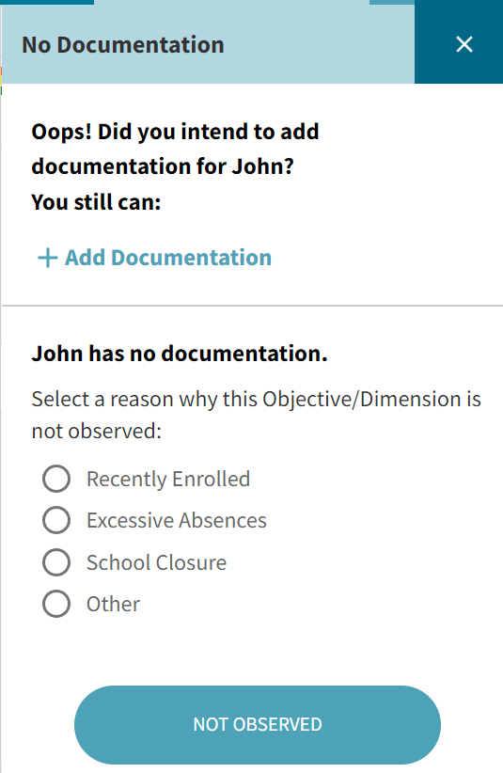
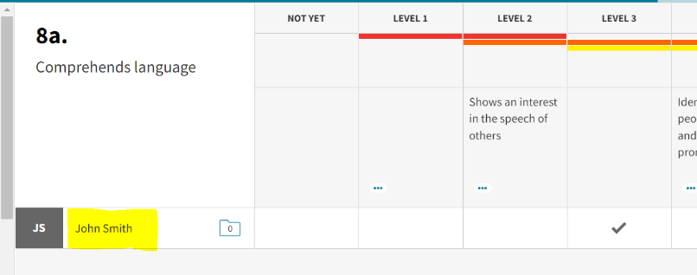
- Not observed: only on rare occasions, such as when the child has been in the program for only a few weeks or has had significant absences during the checkpoint period. To choose not observed, click on the child’s name (highlighted in image below) when you are in the checkpoint and a box to the right will appear that allows you to indicate why the objective was not observed. See images below.

Individual Development and Learning Report
To access the Individual Development and Learning Report once checkpoints are finalized:
Once logged in to Teaching Strategies Gold, click on the REPORT icon at the top of the page.
1. Click on ‘Report’ at the top of the screen.
2. From there, scroll down to ‘Development and Learning’ and click ‘Go’.
3. Choose your class, child, and checkpoint period.
4. Choose EHS’s 5 Areas of Development and Learning
- (Social-Emotional, Physical, Language, Cognitive, and Literacy)
5. Include: Finalized Checkpoints Only
6. Print 2 Copies
- 1 copy of a child's quarterly Development and Learning report is required to be filed quarterly in each child’s individual file.
- 1 copy of a quarterly report is given to the family along with a discussion about the child’s progress.

