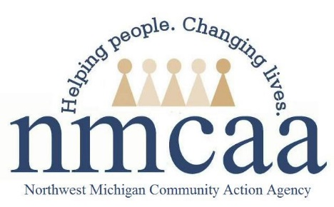

Transitioning Policy and Procedure
1302.70, 1302.72

- Transition planning must begin for a child at least six months prior to their third birthday or anticipated next setting (whichever comes first).
  - Transition activities will be documented in Child Plus under Need Identified – Transition
  - All transition activities will be added under this Need Identified as Actions
  - Transition Activities MUST be added monthly at a minimum
  - The Transition Activities Log is an optional form you can use to document, but all activities, must be transferred to Child Plus
- When transitioning a child from EHS to HS or HS CC, refer to the Procedure for EHS Transition to HS and HS CC Programs,
- EHS children can be transitioned into Head Start programs anytime during the year once the child turns 3.
- Enrolled EHS children can continue to be served after their 3rd birthday to support a successful transition.
- Prior to the start of the school year, the Child Family Specialist (CFS), Teacher and Family Engagement Specialist (FES) will meet to discuss/ensure a successful transition for each EHS child into the HS classroom. Information/documents to be reviewed during the transition meeting include:
- Family Well-being
- Health Requirements
- Child Development
- IFSP/IEP (if applicable)
- Other
- Teachers and FES can find the above documents on Child Plus, Teaching Strategies GOLD, the DECA site, and Learning Genie; these can be used as guides for the Head Start staff. Details of this meeting will be documented by the CFS on the EHS Transition Recap Meeting form located on Weebly (Forms/Transitioning). Copies will be shared according to distribution. Any scheduling difficulties encountered will be discussed with the Program Services Coordinator. CFS will record the transition meeting in Child Plus as an Action under the Need Identified (Transition) under Family Services.
- Over Income (OI) slots cannot be shared between EHS and HS. All options will be considered when HS does not have an OI slot available for an EHS OI child.
- EHS children must have a new application packet completed by a Recruitment and Health Specialist.
- For families and children who move out of the community in which they are currently served, including homeless and foster children, a program must undertake efforts to support effective transitions to another EHS program. If EHS is not available, the CFS will assist the family to identify another early childhood program that meets their needs.
- At the end of each program year, EHS drop files are given to the Program Services Coordinator to be sent to the Traverse City office. Please follow the Drop File Procedure located on Weebly under forms/transitioning. It is required that you put the file in a large manila envelope and label with the child’s name, program name, and CFS name on the top, left, outside corner of the envelope.

4/23 EHS – HS Team: ehs/forms/transitioning

Transition Checklist

❑ At a minimum, 30 months or 6 months prior to transition– Need Identified in CP for Transition Activities
❑ CP documentation at
❑ 6 months ❑ 5 months ❑ 4 months ❑ 3 months ❑ 2 months ❑ 1 month

❑ Transition activities will be planned with the family – activity ideas are listed on the back of the Transition Activity Log

❑ Set up classroom visit (include FES/FSS whenever possible)

❑ Invite FES/FSS to a home visit

❑ Support family in completing pre-application and HS application

❑ Support family in completing health appointments
❑ Well Child Check ❑ Dental

❑ Parent Survey

❑ Complete Transition Recap Meeting form

❑ Complete transition recap with teacher and FES

❑ Drop file – see Drop File Guidance

4/23 EHS – HS Team:ehs/forms/family engagement/transitioning

