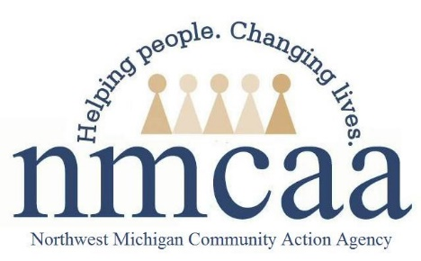

Policy Council and Parent Committee Policy and Procedure
1301.3, 1301.4
- Each Child Family Specialist can have one parent representative elected to Policy Council.
  - Using the Policy Council Flyer, the Policy Council – It’s An Important Role, and the Policy Council Job Description form (found on Weebly under Policy and Procedure – Family Engagement – Policy Council), Child Family Specialists will begin talking to enrolled families about Policy Council beginning in September.
  - Any parent who is interested in running for Policy Council will then fill out a Policy Council Information and Voting form.
  - Once all Policy Council Information forms have been submitted, no later than October 10th, enrolled parents will be given the opportunity to review them and select the individual they feel will best represent their county at Policy Council.
  - Child Family Specialists complete the Elected Policy Council Positions form, according to the results, and will submit the form to Program Support no later than October 30th.
  - The newly elected Policy Council member, Alternate, and outgoing Policy Council member can all receive reimbursement for attending the November Policy Council Meeting. This will be the last meeting for outgoing Policy Council members. After November, the current elected member will receive reimbursement for attending Policy Council. After the November Policy Council meeting, reimbursement will only be provided to Alternate Policy Council members if they are attending in the elected member’s place.
- To help support Policy Council Representative Attendance: Two weeks prior to Policy Council- the CFS will remind their parent reps and verify that they can attend Policy Council that month. If the parent cannot confirm attendance by one week prior to PC, the alternate will be contacted by the CFS to attend.
- Early Head Start Parent Advisory Committees will be established in each county.
  - All parents/guardians of enrolled families are invited to be involved in the parent committee.
  - The Parent Advisory Committee will meet 4x per year (September or October, January, April, and June or July).
  - During the first meeting, current policy council representatives will be invited to provide an overview of policy council and discuss the process for policy council elections. They will be supported by the Socializations Specialist. This information will be delivered by a Socialization Specialist if a policy council member is not available.
  - A Parent Committee Report form can be found on Weebly under Forms – Family Engagement. Parent Advisory Committee report forms should be used for note taking during meetings. This information will then be available to the policy council representative to share at policy council.
- To help with the flow of information to and from policy council in months when parent committees are not held, notes from monthly policy council meetings will be posted in socialization rooms in the parent corner. Parents will be encouraged to connect with their elected policy council member and utilize the parent suggestion forms, also located in the parent corner.

Checklist

 Share the Policy Council Flyer, Policy Council – It’s an Important Role, and Policy Council Job Description with your families in September

 Interested parents will fill out the Policy Council Information and Voting form by October 10

 Share the Policy Council Information and Voting forms with each family; they will select who they feel would best represent them at Policy Council; if only one parent shows interest, voting is not necessary

 Complete the Elected Policy Council Positions Form and return to Program Support by October 30

 Share November date, time and location with the elected Policy Council Representative(s)
 Both the Policy Council Rep and Alternate Policy Council Rep will be reimbursed for November, only one person will be reimbursed in following months

 Remind Policy Council Representative each month to attend Policy Council two weeks prior to the meeting

 Ask your Policy Council Representative to join socializations, specifically when Parent Advisory Meetings are taking place, to share Policy Council information and get feedback from parents at socializations

