Noisy Jungle
Push and Pull Book
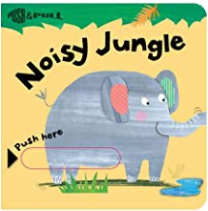

Noisy Jungle is a great book to explore jungle animals with your child.
- Pause and allow your child to use their fingers to push and pull the extended pages.

- Make the sounds of each animal for your child to mimic.

- Identify the words that rhyme in the book.

Thank you to PoWeR! Books Bags
for the generous donation of this book.
www.powerbookbags.com

Noisy Jungle
Push and Pull Book

Noisy Jungle is a great book to explore jungle animals with your child.
- Pause and allow your child to use their fingers to push and pull the extended pages.

- Make the sounds of each animal for your child to mimic.

- Identify the words that rhyme in the book.

Thank you to PoWeR! Books Bags
for the generous donation of this book.
www.powerbookbags.com

Noisy Jungle
Push and Pull Book

Noisy Jungle is a great book to explore jungle animals with your child.
- Pause and allow your child to use their fingers to push and pull the extended pages.

- Make the sounds of each animal for your child to mimic.

- Identify the words that rhyme in the book.

Thank you to PoWeR! Books Bags
for the generous donation of this book.
www.powerbookbags.com

Use the QR link below to explore jungle animal sounds.
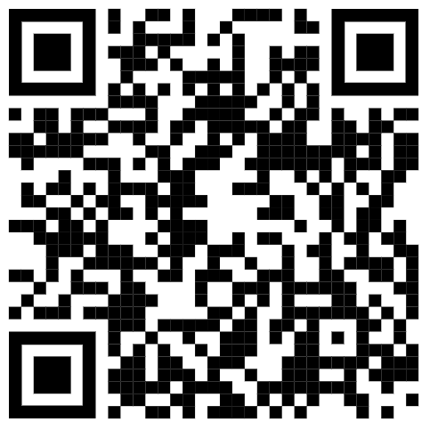
Use the QR link below to explore jungle animal sounds.
Use the QR link below to explore jungle animal song.

