Sunday | Monday | Tuesday | Wednesday | Thursday | Friday | Saturday
Create a consistent bedtime routine for your child. Have a schedule of tasks you do before bed. Example: Put pajamas on, brush teeth, read a book, goodnight song. | Once in the classroom, your toddler will brush their teeth after meals. Have him practice brushing his own teeth after every meal. | Have your toddler use a fork and spoon when eating. They will use utensils in the classroom during mealtime. | Wash hands often. Your child will be washing their hands after many daily transitions in the classroom. | Provide time and opportunities for your child to practice putting on and taking off their coat, hats, gloves, and shoes. | Your toddler will have a rest time in preschool. Designate a “quiet time” in your daily home routine. | Find opportunities for your child to play with other children their age. This will help introduce your child to new friends and experiences
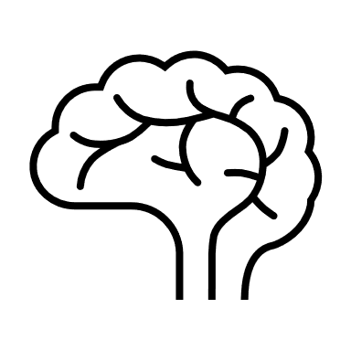 |  | 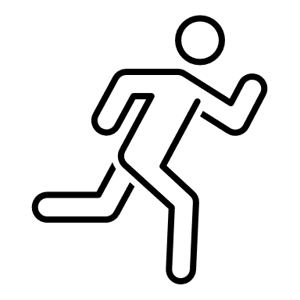
PAT Handout: Routines and Your Baby | Pat Activity:  What My Body Can Do | Pat Activity:  Pretend Tea Party | Pat Activity:  What My Body Can Do | Pat Activity:  Dressing Teddy | Pat Activity:  My Space | Pat Activity:  Ball Play
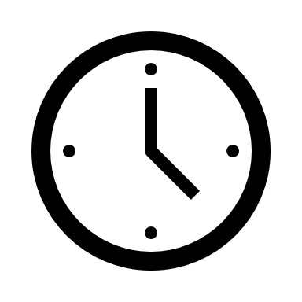 ___________  Estimated: 5 minutes | ___________  Estimated: 5 minutes | ___________  Estimated: 5 minutes | ___________  Estimated: 5 minutes | ___________  Estimated:10 minutes | ___________  Estimated: 10 minutes | ___________  Estimated: 15 minutes

