Sunday | Monday | Tuesday | Wednesday | Thursday | Friday | Saturday
In the bath, support your baby’s head and neck and let him splash his legs in the water. Adult supervision is important for this activity. | Sing “Wheels on the Bus” with your baby and make the hand movements as you sing. Help your baby make the same movements. | After changing your baby’s diaper, gently stretch your baby’s arms and legs out and in towards their belly. | Allow your baby to stretch and roll around on the floor with no restrictions. Be near to observe and keep your baby safe. | Play Pat-A-Cake with your baby and gently help her make the movements with her arms. | Provide safe and clean items for your baby to drop in and take out of a bowl. | With your supervision, allow your baby to touch and pick up leaves and other natural objects outside. Talk about what your baby finds.
 | 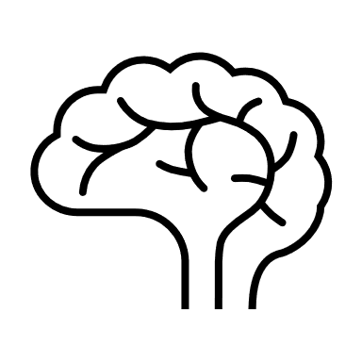
Pat Activity:  Kick the Can | Pat Activity: Music and Me | Pat Activity:  Yoga | Pat Activity:  Bang, Bang, Bang! | Pat Activity:  Baby Games | Pat Activity:  Balls in a Bowl | Pat Activity:  Touch Textures
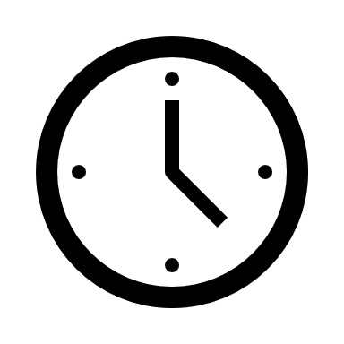 ___________  Estimated: 10 minutes | ___________  Estimated: 5 minutes | ___________  Estimated: 5 minutes | ___________  Estimated: 5 minutes | ___________  Estimated: 5 minutes | ___________  Estimated: 5 minutes | ___________  Estimated:10 minutes

