Sunday | Monday | Tuesday | Wednesday | Thursday | Friday | Saturday
Blow bubbles for your baby to see if she follows them with her eyes or attempts to reach for them. | Lay with your baby on the floor and allow them to move around while you watch and imitate their movements. | Provide time throughout your day to allow your baby to lay on his tummy and build core strength. | Place your baby’s favorite toy in a box that they can reach and try to find. Choose toys that make noise to engage more senses. | Provide your baby with different items to bang on with a wooden spoon- metal bowl, shoe box, plastic container, etc. | Create a safe obstacle course for your baby. Layout her favorite toys out for her to crawl towards. Describe the toys and her movements to her. | Sing rhymes and familiar songs to your child throughout the day. Use hand gestures, wave, and clap!
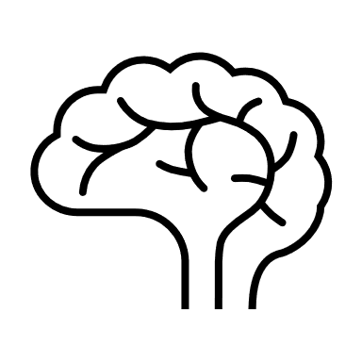
Pat Activity: Dancing Ribbons | Pat Activity:  Baby Games | Pat Activity:  Helping Your Baby Move | Pat Activity:  Find the Toy | Pat Activity:  Causing Effect | Pat Activity:  Cushion Mountain | Pat Activity:  Clap to the Music
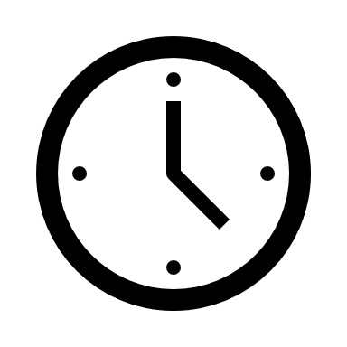 ___________  Estimated: 5 minutes | ___________  Estimated: 5 minutes | ___________  Estimated: 5 minutes | ___________  Estimated: 5 minutes | ___________  Estimated: 5 minutes | ___________  Estimated: 5 minutes | ___________  Estimated: 5 minutes

