Sunday | Monday | Tuesday | Wednesday | Thursday | Friday | Saturday
Hide toys under a blanket or behind your back and let your child find the item. Be playful! | Identify and talk about your child’s different body parts. “I am going to put shoes on your feet”. | Cut a small slit in a shoe box and let your child stick playing cards through the slot. | Provide different size plastic cups for your child to stack together or to make towers. | Count toys as you put them away with your child. | When grocery shopping, identify different items by color, shape, or texture to your child. | Play dress up with your child. Talk about the different clothes and what events they can be worn to.
 |  |  | 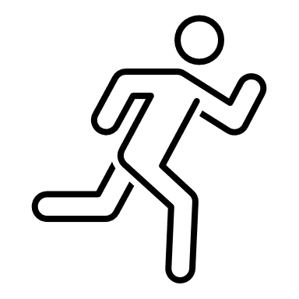
Pat Activity: Where Did It Go? | Pat Activity:  Body Parts | Pat Activity:  Chips in a Can | Pat Activity:  Crazy Cups | Pat Activity:  Egg Carton Game | Pat Activity: Grab It and Name It | Pat Activity:  Hat Head
___________  Estimated: 5 minutes | ___________  Estimated: 5 minutes | ___________  Estimated:15 minutes | ___________  Estimated:10 minutes | ___________  Estimated: 5 minutes | ___________  Estimated:5 minutes | ___________  Estimated:15 minutes

