How to Review and Approve Activities (iPad)
1.a. Log into your Learning Genie Educator App, and click the “Settings” icon. Then, go to “Useful Features” > “In-kind”.
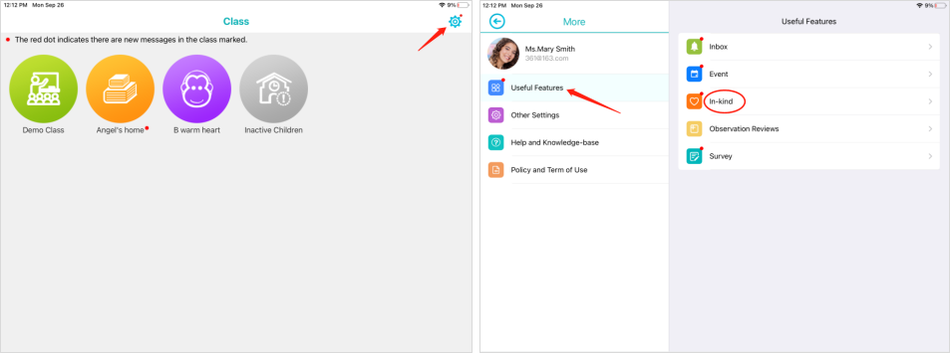
1.b. Click on a classroom, and go to “More”. Then, tap “Useful Features” and select the “In-kind” option, you can also access the in-kind activities.
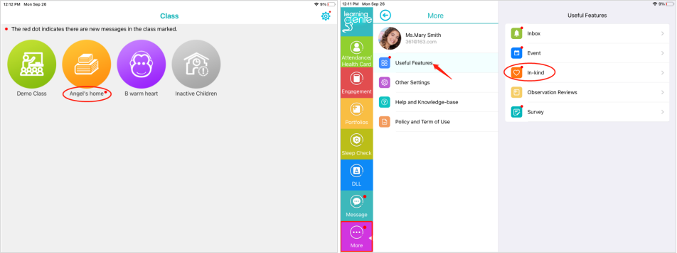
2. Go to the “In-Kind Review” section, and you will be able to find the pending activities that need to be approved.
Note: children with a red dot next to their icons or pictures have pending items.

3. Then you can choose what you want to do with the activities:
- Approve: activities will officially be in the in-kind reports.
- Ignore: activities will not be counted towards your reports.
- Reject: activities will be sent back to the parent to be corrected.
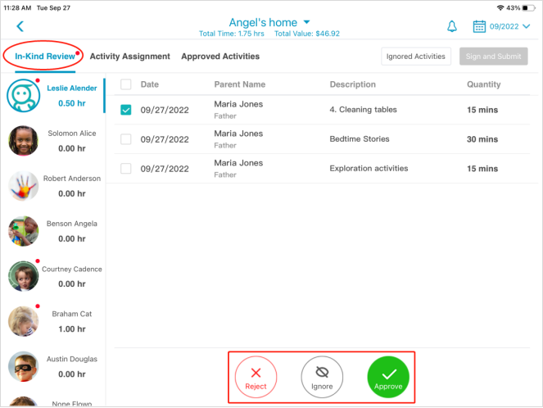
4. At last, click the “Sign and Submit” button.

