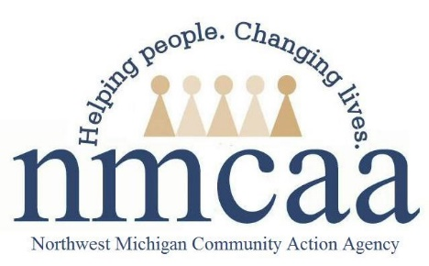

Home Visit Policy and Procedures
HSPPS 1302.22, 1302.35
- Full time CFS’s carry a caseload of 10 families.
- A minimum of 46 home visits, lasting 1.5 hours, are offered to each enrolled family per year. The visits promote high-quality early learning experiences and growth towards the goals described in the Head Start Early Learning Outcomes Framework..
  - Home visits must take place in the home (unless there is a temporary situation where the home environment is not available).
  - Home visits are conducted with parents/legal guardian and are not conducted when only babysitters or other temporary caregivers are present.
  - The PAT Foundational Personal Visit Plan or the Personal Visit Planning Guide is the tool used to intentionally plan home visits, jointly by the home visitor and parents that are individualized to the developmental needs of the child, using information from ongoing assessments, parent input and the child development goal.
  - Every attempt should be made to reschedule missed visits with families within the same week to ensure the minimum home visit frequency requirements are met. If a home visit is missed, the reason for the missed visit must be documented along with attempts to reschedule the visit in Child Plus.
  - Weekly home visits last at least an hour and a half.
  - CFSs receive $20 a month for curriculum needs for home visiting. Turn in all receipts on a weekly basis to your PSC and the Business Office with appropriate tracking documentation.
- The Parents as Teachers (PAT) curriculum is implemented at home visits providing high-quality early learning experiences in language, literacy, mathematics, social and emotional functioning, approaches to learning, science, physical skills and creative arts.
- Curriculum implementation and fidelity is monitored using the PAT Personal Visit Observation Tool.
  - Using the HOVRS bi-monthly, new CFS’s are observed until 6 months after their PAT Foundational Training. At this time, the PAT Home Visit Observation Tool is used bi-monthly for the remainder of the year. Staff are provided with feedback as support for continuous improvement of implementation.
  - CFSs in their 2nd year of employment and beyond are observed two times per year and are provided with written and verbal feedback as support for continuous improvement of implementation. This feedback is provided as part of a discussion between the Coach and CFS; trainings may be identified as needed or a referral to coaching might be made. The observations can support CFS in choosing the Professional Development they choose with their Coach

7/22 p:hs/ehs/enrollment/enrollment documents

Home Visit Checklist

q A minimum of 46 visits are offered a year to each family

q Visits are an hour and a half at a minimum

q Home visits take place in the home (unless there is a temporary situation where the home environment is not available)

q The PAT Foundational Visit Plan or Personal Visit Guide is completed PRIOR to the home visit

q In kind is documented through a conversation about time spent since the last visit completing extension activities

q During the visit, the next visit is planned (time, activity, materials)

