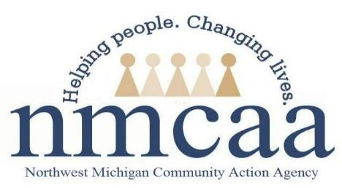

Home Based Caseload Policy and Procedure

HSPPS 1302.22 (b): Caseload. A program that implements a home-based option must maintain an average caseload of 10 to 12 families per home visitor with a maximum of 12 families for any individual home visitor.

As a top priority, NMCAA’s Early Head Start Home Based option will strive to maintain full enrollment across the program, enrolling families among part-time and full-time staff equitably, taking Comprehensive Coaching and wait lists into consideration.

Full enrollment for Early Head Start Home Based is 233 families.

Procedure
All full-time staff will have 10 families. Considerations that may effect this number will be:

- Staff who are improving their home visiting practices through Comprehensive Coaching will be fully enrolled with 9 families. They will use 4 hours a week to meet with their coach, attend applicable trainings and support their Shared Goal and Action Plan, while teaming with their coach.
  - The Coach will share with the PSC who is receiving Comprehensive Coaching; this will happen in July to coincide with transitions. When a family is transitioned out during the summer, and a CFS is identified as accepting Comprehensive Coaching, the family will not be replaced, as this CFS will be fully enrolled September-May with 9 families.
  - The CFS will enroll to 10 families when the coaching cycle comes to an end in May

- A CFS may be fully enrolled with 9 families if the wait list is low or non-existent in the CFS’s area; CFS will support recruitment activities 4 hours a week or support staff vacancies/absences by subbing.
  - When transitions happen in the spring, if there are low wait lists or a staff vacancy, staff may drop to 9 families for full enrollment
  - CFS’s with a full enrollment of 9 will be identified by the PSC team and Manager.

A maximum of 2 CFS across our program at any given time will have the option to be fully enrolled at 9; this will support program full enrollment of 233

7/23 EHS/HS Teams/ehs/enrollment

