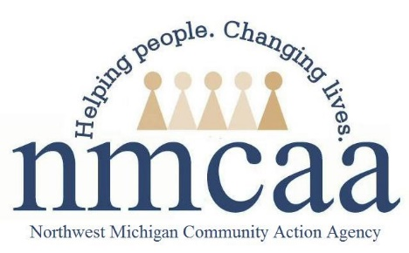

EHS Family and Community Engagement Program Services Policy and Procedure

HSPPS 1302.50, 1302.51, 1302.52
- The Parent, Family, and Community Engagement (PFCE) Framework is a roadmap for progress in achieving the types of outcomes that lead to positive and enduring change for children and families.
- Family engagement refers to all activities that parents do to help their children succeed. Staff can encourage family engagement by recognizing parents as their children’s primary teachers and nurturers, supporting parent-child relationships, encouraging trust and ongoing two-way communication between staff and parents, and providing parents with opportunities to participate in the program.
- CFS and R&H staff are responsible for building partnerships with families and integrating parent and family engagement strategies into all systems and program services to support family well-being and promote children’s learning and development. A more complete guide to the family partnership process can be accessed on the EHS Weebly site under the Family Partnership Process tab. 1302.50
- Positive goal-oriented relationships with families contribute to successful partnerships. These relationships are grounded in a strengths-based approach that identifies, celebrates, and draws on the strengths of families. As part of the family partnership process:
  - R & H will complete Community Connections and facilitate referrals based on family and child strengths, needs, and requests.
  - CFS will review the Family Partnership Agreement outlining the family engagement and parent involvement to promote child learning and development.
  - CFS will plan home visits and facilitate referrals based on family and child strengths, needs, and requests. All referrals or individualized direct services, including follow-up, provided to families will be tracked by the CFS in Child Plus.
  - Early Head Start will use the EHS Needs Assessment and Family Outcome Tool in their discussions with families to assist in identifying family strengths and needs in the areas of family well-being and financial stability, parent literacy, adult and post-secondary education, employment, and family relationships.
  - The CFS is responsible for completing the Needs Assessment once a year and the FOT in the Fall and Spring with families, entering the data into Child Plus. Data from surveys can be entered at any time during the quarter. See the Needs Assessment/FOT guidance on the EHS Weebly site (Forms/Enrollment) for more information.
- The family partnership goal is also a part of the family partnership process. The family partnership goal is an individualized, strengths-based, family-driven process that is jointly developed and shared with parents in which staff and families review individual progress, revise goals, evaluate and track whether identified needs and goals are met, and adjust strategies on an ongoing basis, as necessary.
- The family partnership goal outlines family goals and the way that the family and EHS staff can work together to achieve those goals.
- Each family partnership goal is unique; the family is always the senior partner
- Whatever direction the family partnership agreement takes, it can be achieved by establishing strategies, responsibilities, and timetables.
  - Partnership tools may include Circle of Support, Family Partnership Strengths and Interests, Partners for a Healthy Baby activities, or any other tools that will support the goal setting process.
  - Any partnership tool used in the Family Partnership Process should be recorded in Child Plus.
  - Identified goal/s and steps for completion will be reflected on the Family Partnership Goal sheet. CFSs are responsible for recording the family goal along with progress on family goals monthly, at a minimum, and will document status, along with progress and referral information, in Child Plus.

- EHS staff will take into consideration any existing plans the family may have with other community agencies and availability of other resources to address family needs, strengths, and goals, in order to avoid duplication of efforts.

7/22 p:hs/ehs/ parent involvement/social services

Checklist

q Reviewed the Community Connections form prior to enrollment, followed up on any needs identified on the Community
Connections form with the family

q Family Partnership Agreement has been reviewed and signed
q This is documented under the Family Partnership tab in Child Plus

q Needs assessment and Family Outcomes Tool is complete
q This is documented in the Family Partnership tab
q The Needs Assessment and FOT results are documented in CP
q Referrals and Direct Services requested on the above forms are completed with the family and documented in CP

q A family partnership goal is identified with the family within 90 days of enrollment, unless approved by PSC and reason
documented in CP.
q The family partnership goal is documented on the Family Partnership Goal sheet, with a copy in the child’s file.
q The family partnership goal is documented in CP under Family Services and reviewed monthly.

